REPORT TO: NEIGHBOURHOOD SERVICES COMMITTEE – 22 NOVEMBER 2021
REPORT ON: DUNDEE STRATEGIC HOUSING INVESTMENT PLAN
REPORT BY: EXECUTIVE DIRECTOR OF NEIGHBOURHOOD SERVICES
REPORT NO: 302-2021

- PURPOSE OF REPORT

1.1 To seek approval of the Strategic Housing Investment Plan (SHIP) 2022-2027. (See Appendix I).

- RECOMMENDATION

2.1 It is recommended that Dundee City Council, Neighbourhood Services Committee approves:

    - The content of the Strategic Housing Investment Plan, 2022-2027.
    - Submission to the Scottish Government.

- Financial Implications

3.1 Scottish Government have issued Resource Planning Assumptions at local authority level for the Affordable Housing Investment Programme to 2025/2026., these are detailed in the table below:
 | 2021/22 | 2022/23 | 2023/24 | 2024/25 | 2025/26 | Total
Grant (Millions) | 19.977 | 17.219 | 17.170 | 17.230 | 17.516 | 89.112

4. Background

4.1 The Strategic Housing Investment Plan (SHIP) is the key statement of affordable housing development priorities within local authority areas. The Scottish Government Affordable Housing Investment Programme Resource Planning Assumption for the City made almost £70.5 million available from 2016/17 to 2021. As outlined in the table above the Scottish Government has outlined an additional £89.112 million Resource Planning Assumptions at local authority level for the Affordable Housing Investment Programme to 2026.

Impact of COVID-19

4.2 The Scottish Government has recognised that due to the strain of the COVID-19 pandemic on the country`s public services.

Delivering the housing development programme

  - To promote the delivery of the SHIP 2021-2026 programme, Dundee City Council (DCC) Neighbourhood Services will continue to work in partnership with: DCC City Development; Scottish Government; Registered Social Landlords; and the Private Housing Sector to explore all possible housing development options that will help maximise the delivery programme.

  - An example of this successful, partnership collaboration can be observed at Table 1, which demonstrates a significant number of affordable rented new-build houses that are currently on site or due to start onsite this financial year.

  - This achievement is a direct result of the aforementioned SHIP partnership working arrangement. The houses were delivered through the previous Strategic Housing Investment Plan, 2021-2026.

Table 1. Dundee SHIP Commissioned New-Build Affordable Rented Housing:
Name of Development | Tenure | Number of Houses
Derby Street | SR | 163
Seagate | MMR | 28
Pitkerro Road | SR | 30
Ellengowan Drive | SR/MMR | 130
South Victoria Dock Road | MMR | 119
Former Charleston Primary School | SR | 44
Haddington Avenue | SR | 24
Candle Lane | SR | 24
Langlands Street | SR | 16
Former St Vincents Primary School | SR | 21
Total | - | 599
Tenure SR: Social Rented
Tenure MMR: Mid-Market Rent
N.B. Table 1: Developments are currently on site or are due to start on site this financial year
Data as at September 2021

  - The DCC Neighbourhood Services Committee`s approval of the SHIP, 2021-2027 will ensure that the city continues to successfully deliver new-build affordable housing rental options for the citizens of Dundee. Thereby, positively contributing to one of the key outcomes of the City`s Local Housing Strategy: to meet housing need and demand.

- POLICY IMPLICATIONS

  - This report has been subject to an assessment of any impacts on Equality & Diversity, Fairness & Poverty, Environment and Corporate Risk. A copy of the Impact Assessment is available on the Council’s website at www.dundeecity.gov.uk/iia.

- CONSULTATIONS

  - The Council Management Team has been consulted in the preparation of this report and agree with its content.

- BACKGROUND PAPERS

  - None

Elaine Zwirlein
Executive Director of Neighbourhood Services 26 October 2021

Appendix I

DUNDEE

STRATEGIC HOUSING INVESTMENT PLAN
2022 – 2027

Introduction
Dundee`s Strategic Housing Investment Plan (SHIP) 2022-27 sets out the priorities of the Council and its partners for the expenditure of the Scottish Government’s Affordable Housing Supply Programme funding. The SHIP is a rolling plan/programme covering a period of five years. It delivers the affordable Housing priorities set out in the Local Housing Strategy (LHS) and the Local Development Plan.
The SHIP is embedded in Dundee`s Community Partnership Planning Framework. It reflects the affordable housing priorities within the city`s eight Local Community Planning Partnership areas and multi member ward boundaries.
Resources to Deliver the SHIP Programme
The Strategic Housing Investment Plan (SHIP) is the key statement of affordable housing development priorities within local authority areas. The Scottish Government Affordable Housing Investment Programme Resource Planning Assumption for the City made almost £70.5 million available from 2016/17 to 2021. Scottish Government has outlined an additional £89.112 million Resource Planning Assumptions at local authority level for the Affordable Housing Investment Programme to 2026. these are detailed in the table below.
 | 2021/22 | 2022/23 | 2023/24 | 2024/25 | 2025/26 | total
Grant (Millions | 19.977 | 17.219 | 17.170 | 17.230 | 17.516 | 89.112

Additionally, the Council has identified an additional £6 million of borrowing in 2021/22 to expedite building additional Council Housing.

Changes to existing SHIP priorities due to the impact of COVID-19.
There are not any significant changes to the priorities within the SHIP owing to the impacts of Covid-19. There have been some delays to site development owing to the closure of sites between March and July 2020 but all developments are now back on site.
The Council has agreed a Recovery Plan which has been integrated within the Council’s Service Plans.

Risks to programme delivery
The main delivery risk to the City`s Affordable Housing Supply (AHS) Programme is inflation in costs of building materials and disruption to supply chains caused by Covid and exiting from the European Union. These factors are also causing difficulties in contracting labour and site managers. Further to these headwinds is the availability and ownership of land suitable for the development of new housing. Negotiations are underway between Registered Social Landlords (RSLs) and owners of land in private ownership, but ultimately land values must be capable of being supported by the finance available to deliver affordable, new-build housing within Scottish Government`s development benchmark costs.
Additional risks to the City`s delivery programme relate to issues regarding the disposal of surface drainage water in new housing developments. This sometimes involves the development of very, expensive site drainage infrastructure design. As a result, these additional costs are presenting challenges to the viability of some SHIP development sites. The Council continues to work closely with Scottish Water and the Scottish Government to address these issues. However, it is anticipated that owing to the infrastructure and highly urbanised nature of all sites in the city, surface water drainage will continue to cause difficulty and additional costs for many of the City`s SHIP development sites.

Completions
The Council has set itself a challenging target of 200 social rented house completions per annum within the Local Housing Strrategy and Council Plan. These targets wave not been met in recent years (see table below).
2015/16 | 2016/17 | 2017/18 | 2018/19 | 2019/20 | 2020/21
108 | 138 | 62 | 161 | 58 | 27

Increases in completions are expected in 2021/22 being close to or possibly exceeding the target though difficulties with supply cahains and labour may yet have an impact. However, we have a healthy pipeline of projects and and developments on site which should result in improved outcomes.
Photographs of recently completed and some ongoing development sites can be seen at Appendix 2.

Identification/Prioritisation of Sites
At the centre of the identification/prioritisation of SHIP development sites is DCC Council / Registered Social Landlord (RSL) strategic planning framework. Within this framework, RSLs submit details of their proposed SHIP developments on an annual basis. DCC Neighbourhood Services (NS) also follows this process for sites that it has identified. RSL and DCC NS submissions primarily focus on the following housing development aspects:
- Location of Development
- Name of Developer
- Number of proposed units to be developed
- Number of general needs units to be developed
- Number of particular needs units to be developed
- Level of Scottish Government Grant funding required for development.
Submitted development sites are reviewed collectively by DCC: Neighbourhood Services (Housing); City Development (Planning); and City Development (Property). Prioritisation assessment criteria is used to rank each site. Ranking order ranges from high, medium or low priority. The categories used within the assessment criteria are as follows:
- Sites within regeneration areas including the City Centre Strategic Investment Plan
- Sites identified within the previous SHIP
- Site prioritisation in the Local Development Plan
- Improving housing and tenure balance in the area
- Provide an appropriate mix of property types and sizes
- Meet affordable housing need in the area
- Sustaining existing stable neighbourhoods; mitigating further deterioration and deprivation in these communities
- Innovation and Sustainability
- Provide housing for particular needs housing groups
- Land Ownership
- Deliverability.
Furthermore, the prioritisation process is complimented by formal discussions with representatives of: individual RSLs; DCC Neighbourhood Services; and Dundee Health and Social Care Partnership.
All developments supported by the prioritisation assessment criteria are included and prioritised in the SHIP.
Those developments with a higher priority will attract funding first. When a higher priority development starts on site, subject to agreement with the Scottish Government, it will continue to receive SHIP funding until the development is complete.

Future Priorities: Increasing Housing Options in the City
Dundee City Council is accelerating the preparation of a long-term City Centre Strategic Investment Plan (CCSIP). This plan will identify opportunities for housing development within the City Centre. As such, we will prioritise development opportunities for the Affordable Housing Investment Plan in future years.
In addition, the Council will consider the purchase of suitable, open-market properties to meet the City`s general social housing needs, which includes the housing requirements of extended families, and people with particular needs. This option will also be considered in the delivery of Dundee`s Rapid Rehousing Transition Plan.

Housing for Particular Needs
We will aim to achieve a minimum of ten wheelchair standard houses per annum. Additionally other particular needs housing will be incorporated in developments taking into account the needs identified in the Dundee Health and Social Care Partnership’s Strategic Needs Assessment and Strategic Plan.

Child Poverty Action Report
The city is setting itself the ambitious goal of matching the Scottish Government’s overall national target of reducing child poverty to less than 10% of children living in relative poverty.
This work is progressing against the backdrop of the current situation in Dundee, where the rate of children in relative low-income households after housing costs at the end of March 2020 was 27%.
The Council’s combined Fairness and Local Child Poverty report outlines how the experience of people living in poverty is absolutely crucial in taking forward policies, and how local solutions are being developed to tackle poverty in city neighbourhoods.
The action plan highlights work that is ongoing across the city including the Cost of the School Day project, the Dundee Food Insecurity Network, the Discover Work service, digital inclusion and the Alcohol and Drug Partnership’s action plan for change following the report of the Dundee Drug Commission.
Housing plays a significant role in addressing child poverty – the delivery of affordable housing and tackling homelessness throughout Rapid Rehousing Transition Plan are core to achieving the City’s outcomes for child poverty

Sustainability
The Council will work with partners to ensure that all new build properties constructed within the investment programme will meet or surpass the current building regulations and that energy efficiency measures such as insulation, solar energy, wind power or other suitable measures are integrated. This will assist in reducing carbon emissions, address fuel poverty and ensure that tenants live in warm, affordable homes.

Equalities
All procurement strategies and contracts will be screened and where appropriate undergo an Equalities Impact Assessment screening to ensure that actions associated with this strategy support the equalities agenda of the government, council and its partners.
A specific aim of this strategy is to deliver affordable and good quality housing for:
- Ethnic Minorities including economic migrants
- Particular Needs Housing Groups
- Gypsy / Travellers
- Homeless people.
An increase of appropriate provision for these groups will be encouraged over the period of plan.
In addition, it should be noted that the accommodation needs of individuals with particular needs requiring new-build supported, adapted or wheelchair housing have been taken account of within the SHIP. Discussions on the appropriate models of accommodation, number of houses, locations,and funding for these types of housing over the period of the SHIP are currently ongoing with commissioners. A summary of the particular needs housing targets over the period of the SHIP is outlined at Table 3.
Strategic Housing Investment Plan – Programme 2021-2026
The details of the programme are outlined at Tables 1 and 2.
An overview summary of the Tables:
Table 1: Details the development programme for 2022/2023 to 2023/24. This includes sites which have existing commitment; but where all funding has not yet been drawn down (carry forward). It also contains new sites where DCC Neighbourhood Services expects there to be approvals and grant claims prior to the end of financial year 2024.
Table 2: Identifies pipeline projects for 2024 to 2027. Where appropriate, projects may be brought forward should funding be available.
.
Table 1. SHIP Housing Programme 2022/23 - 2023/24
Project Name | Housing Developer | Number of Units | Tenure | Total Grant (£million) | Estimated Spend  2022-2023 | Estimated Spend  2023-2024 | Site Start | Completion
Former St Lukes & St Matthews Primary School / Longhaugh Primary School sites | Angus HA | 74 | SR | 5.328 | 1.000 | 0.000 | Jan’  2021 | May  2023
Whitfield Drive/Lothian Crescent Phase 1 | Angus HA | 18 | SR | 1.474 | 0.474 | 1.000 | Jan’  2022 | Sept’  2023
Former St Vincents Primary School site, Pitkerro Road | Angus HA | 21 | SR | 1.512 | 0.985 | 0.527 | Jan’  2022 | April  2023
Balgowan Square Kirkton | Angus HA | 8 | SR | 0.660 | 0.000 | 0.660 | April 2023 | March 2024
Balmuir Road Kirkton | Angus HA | 10 | SR | 0.819 | 0.000 | 0.889 | April 2023 | March 2024
Buttars Road/Brownhill Street, Charleston | Blackwood HA | 21 | SR | 1.875 | 0.715 | 0.800 | 2021 | 2023
Brownhill Place/Gourdie Place/Invercraig Place, Charleston | Blackwood HA | 45 | SR | 3.983 | 1.573 | 1.900 | 2021 | 2023
Coldside Road, Coldside | Caledonia HA | 30 | SR | 2.552 | 1.052 | 0.000 | Oct  2021 | March  2023
Morgan Street, Stobswell | Caledonia HA | 37 | SR | 2.179 | 1.679 | 0.000 | Jan’  2022 | June  2023
Project Name | Housing Developer | Units | Tenure | Total Grant (£M’s) | Spend 22/23 | Spend 23/24 | Start | Completion
Former Rosebank Primary School site, Hilltown | Caledonia HA | 30 | SR | 2.482 | 1.482 | 0.000 | Nov’  2021 | Oct’  2022
Raglan Street, Stobswell | Hillcrest HA | 16 | SR | 1.330 | 1.000 | 0.000 | Aug’  2022 | March  2024
Former St Mary's Primary School, Lochee | Hillcrest HA | 28 | SR | 1.728 | 1.328 | 0.000 | Oct’  2022 | March  2024
Pitkerro Road, Midmill | Home HA | 29 | SR | 2.700 | 0.350 | 2.350 | Jan’  2022 | Sept’  2023
Mill O' Mains (Phase 4), Mill O` Mains | Home HA | 45 | SR | 3.240 | 1.933 | 1.307 | April  2022 | July  2023
Murrayfield Terrace, Whitfield | DCC | 43 | SR | 2.537 | 2.000 | 0.537 | April  2022 | July  2023
Gellatly Street, City Centre | Hillcrest HA | 49 | SR | 3.760 | 1.100 | 2.000 | July  2022 | Jan’  2024
Burnside Mill, Lochee | Hillcrest HA | 54 | SR | 4.430 | 1.730 | 2.000 | Oct’  2022 | March  2024
High Street, Lochee | Hillcrest HA | 20 | SR | 1.800 | 1.000 | 0.800 | April  2022 | Sept’  2023
Former Maryfield House Site , Mains Loan, Stobswell | Sanctuary HA | 40 | SR | 3.310 | 0.000 | 1.510 | April  2023 | April  2024
Ballindean Road, Douglas | Caledonia | 73 | SR | 5.256 | 1.500 | 3.756 | June  2022 | Dec’  2023
Project Name | Housing Developer | Units | Tenure | Total Grant (£M’s) | Spend 22/23 | Spend 23/24 | Start | Completion
Former Gowriehill Primary School site, Menzieshill | Angus HA | 35 | SR | 2.867 | 0.000 | 1.250 | April  2023 | Dec’  2024
Blackness Road, West End | DCC | 26 | SR | 1.274 | 1.000 | 0.274 | June  2022 | July  2023
Former Park Hotel, Coupar Angus Road | Hillcrest | 18 | SR | 1.530 | 1.030 | 0.000 | Feb’  2022 | Oct’ 2023
Aberdour Place | Hillcrest | 22 | SR | 1.738 | 0.400 | 1.338 | Jan’  2023 | Aug’ 2024
Murraygate | Hillcrest | 31 | SR | 2.460 | 1.460 | 0.000 | Sept’ 2021 | March  2023
Buchanan St | Hillcrest | 12 | SR | 0.936 | 0.936 | 0 | Aug 21 | Jan 23
Ellengowan Ph2 | Hillcrest | 61 | SR | 3.800 | 1.000 | 2.800 | July 22 | Oct 24
Grand Total |  |  |  |  | 26.727 | 25.698
HA: Housing Association
DCC: Dundee City Council
TBC: To be confirmed
Tenure: SR - Social Rented, MMR – Mid market rent

Table 2. SHIP Housing Programme: Pipeline Projects, 2025 – 2027

Project Name | Housing Developer | Number of Units | Tenure | Total Grant (£million) | Tender Submission
Former Mossgiel Primary School, Linlathen | Abertay HA | 44 | SR | TBC | TBC
St Mary’s Place, Lochee | Hillcrest HA | 16 | SR | TBC | TBC
Dundee College, Constitution Road,  City Centre | TBC | TBC | TBC | TBC | TBC
Angus / Tannadice Works, Neish Street/North Isla Street, Maryfield | Hillcrest HA | 95 | TBC | TBC | TBC
Rosebank Street, Hilltown | Hillcrest HA | 24 | TBC | TBC | TBC
Bank Street, Lochee | Hillcrest HA | 16 | TBC | TBC | TBC
Francis Street | Hillcrest | 12 | SR | TBC | TBC
North Lindsay Street | Hillcrest | 29 | SR | TBC | TBC
Trades Lane / Former Stagecoach | Hillcrest | TBC | SR/MMR | TBC | TBC
Whitfield Drive/Lothian Crescent Phase 2 | Angus HA | 14 | SR | 1.147 | TBC
Haldane Tce | Angus HA | 6 | SR | 0.492 | 2024
St Marys/St Fillans | Angus HA | 17 | SR | 1.392 | 2024
Rowantree Crescent, Linlathen | Angus HA | 10 | SR | 0.819 | 2023
 | Total | 283 |  |  | -
HA: Housing Association
DCC: Dundee City Council
TBC: To be confirmed

Appendix 1 – Recent Affordable Housing Completions and Sites under Development
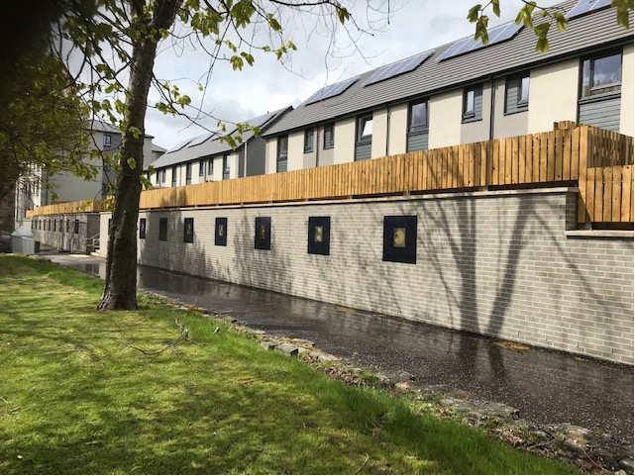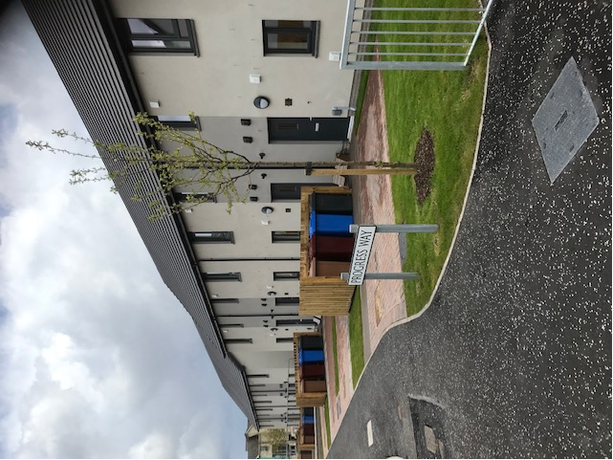
Caledonia HA – former I.B. Connex site Mawelltown

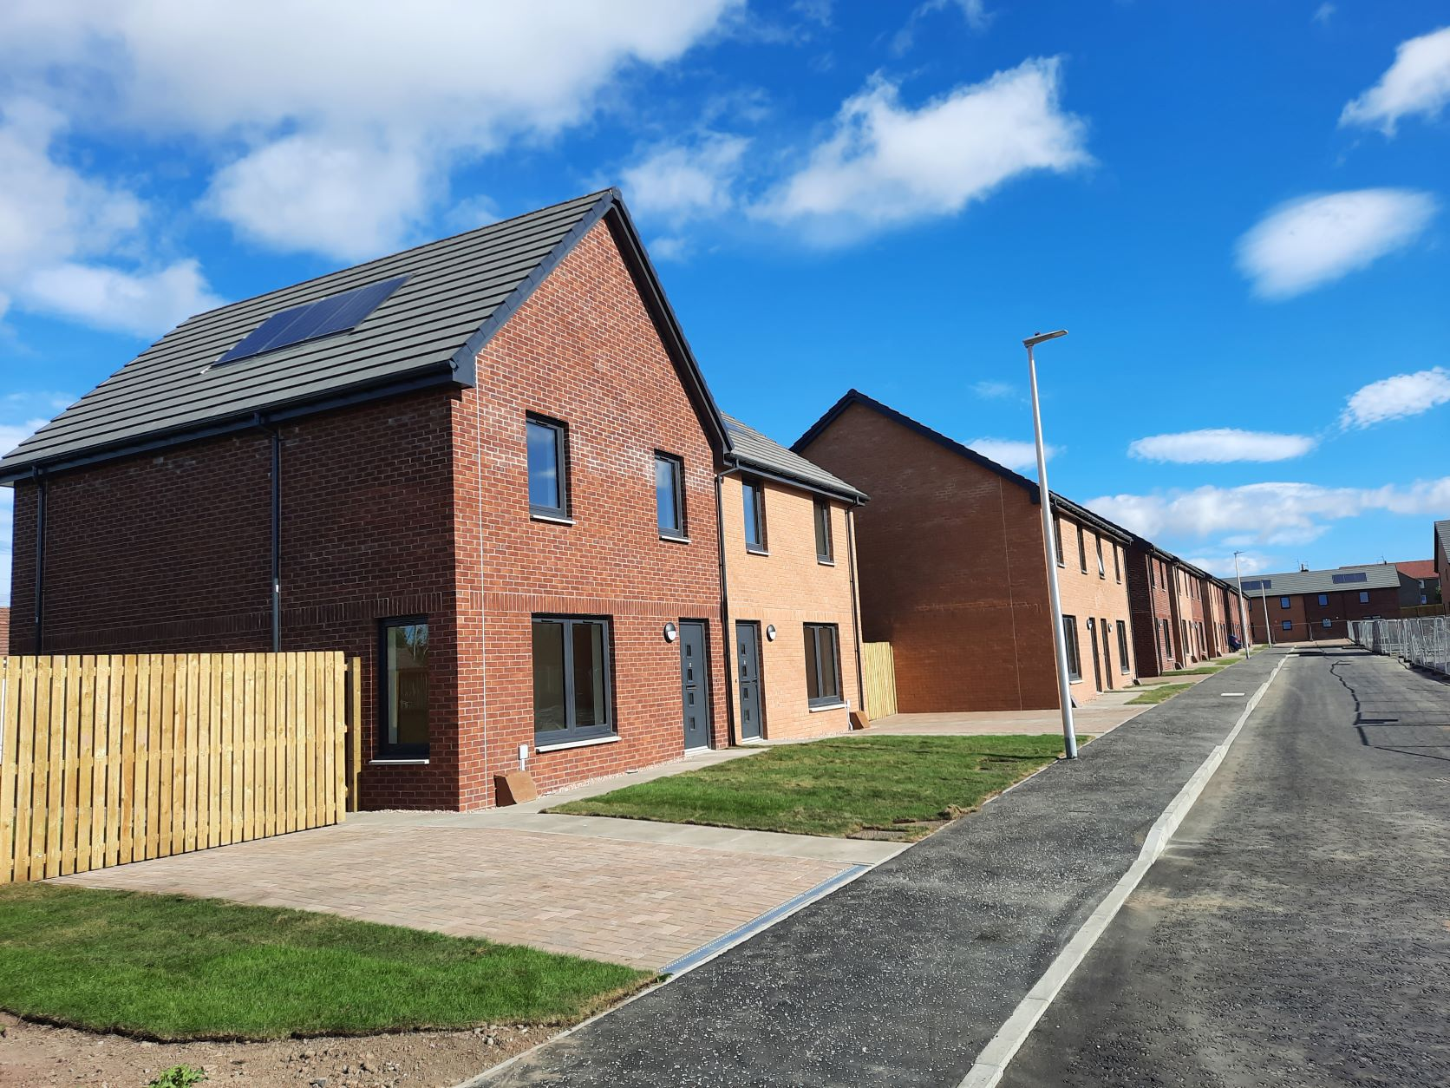
Angus HA Former Charleston Primary School

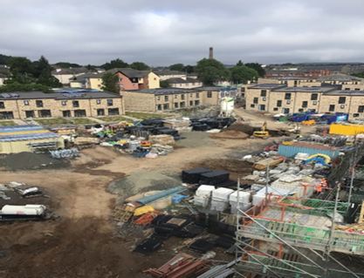
Ongoing development at Derby Street (Hillcrest HA).

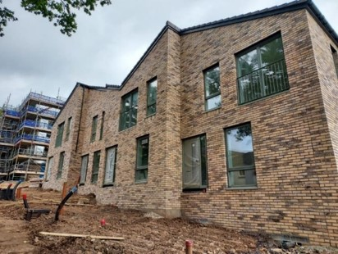
Ellangowan Drive - Hillcrest
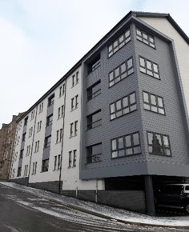
Benvie Road - Hillcrest

