Screening Determination: SEA not Required – Section 8(1)

DUNDEE CITY COUNCIL
Biodiversity Action Plan

The Environmental Assessment (Scotland) Act 2005

Screening Determination under Section 8(1)

Section 8 (1) of the Environmental Assessment (Scotland) Act 2005 requires Local Authorities to determine if a plan is likely to have significant environmental effects.

Dundee City Council has determined, in consultation with Scottish Environment Protection Agency, Scottish Natural Heritage and Historic Scotland, that the Biodiversity Action Plan is unlikely to have significant effects that would require a strategic environmental assessment.

A Strategic Environmental Assessment will therefore not be prepared alongside the Biodiversity Action Plan.

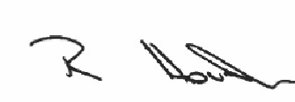

Signed…………………...................... Date....18/07/2019.............................

Rod Houston
Senior Manager Environment

