DUNDEE CITY COUNCIL

REPORT TO: Policy and Resources Committee - 22 August 2011

REPORT ON: Scoping Exercise with BME Communities (Black and Minority Ethnic)

REPORT BY: Director, Leisure and Communities

REPORT NO: 265-2011

- PURPOSE OF REPORT

  - To report on the scoping exercise, with young people in Black and Minority Ethnic communities in Dundee, commissioned from the Yusuf Youth Initiative as approved by Council on 13th September 2010 (Report No. 560-2010).

- RECOMMENDATIONS

It is recommended that:

  - Committee notes the findings of the Scoping Exercise. (See appendix 1).

  - Committee approves recommendations contained in the Scoping Exercise Report.

- FINANCIAL IMPLICATIONS

  - There are no additional financial implications arising from the Action Plan.

4.0 BACKGROUND

4.1 Since 2005 CLD Youth Workers in the Leisure and Communities Department have worked closely with the Yusuf Youth Initiative to build cultural links between young people from different backgrounds in Dundee. This cultural integration work has focussed largely on links with young Muslim men in Dundee.

4.2 As a result of the cultural integration work it was recognised that there was a need to better understand the needs and interests of young people in the broader BME communities in Dundee. The proposal for a Scoping Exercise was approved by Council on 13th September 2010.

  - The Yusuf Youth Initiative was engaged to carry out the scoping exercise between October 2010 and April 2011.

  - The Scoping Exercise has resulted in a report which outlines recommendations from discussions with the leaders of the main organisations in Dundee's BME communities and young people involved with these organisations.

  - As a result of this report several actions will develop and will be ongoing. These actions can be summarised as:

- Building on the network of contacts established through the Scoping Exercise to further develop opportunities for young people from all backgrounds.

- Providing support to BME community organisations to enable them to build their capacity to deliver programmes of activity of interest to their young people.

- Seeking stronger representation from BME communities to the new Dundee Youth Council.

- Sharing the findings from the Scoping Exercise with colleagues in the Discover Learning Partnership and the Dundee Carers Centre.

- Developing more effective ways of communicating information about opportunities for young people to BME communities.

- Exploring ways in which higher profiles can be given to community celebrations.

  - POLICY IMPLICATIONS

  - This report has been screened for any policy implications in respect of Sustainability, Strategic Environmental Assessment, Anti-Poverty and Risk Management.

Implementation of the recommendations arising from this report will positively contribute to the Council's equalities objective.

5.2 An Equality Impact Assessment has been carried out and will be made available on the Council website http://www.dundeecity.gov.uk/equanddiv/equimpact/. The EQIA acknowledges the need for providers of services for young people to be sensitive to any cultural or religious needs and the importance that language plays in helping people to feel integrated with a community.

- CONSULTATION

  - The Chief Executive, Depute Chief Executive (Support Services) and Director of Finance have been consulted on this report.

- BACKGROUND PAPERS

  - Equality Impact Assessment

STEWART MURDOCH
DIRECTOR, LEISURE AND COMMUNITIES
10 AUGUST 2011

Youth work support needs for bLACK AND MINORITY ETHNIC young people
a scoping exercise

MAY 2011



34 Bellfield Street
Dundee
dd1 5hz

Contents

Foreword 2

Methodology 3

Background Reading 4

Full Report 5-8

Summary of Findings and Recommended Actions 9-10

Appendices 11-16

Foreword

This report is the result of a scoping exercise carried out by the Yusuf Youth Initiative in 2010-2011. The report is the culmination of a six month process which involved reaching out to BME community groups that have a youth work focus and the young people themselves.
The Yusuf Youth Initiative was commissioned by Dundee City Council to carry out the scoping exercise. The exercise intended to:
- Establish contact with key communities, develop a network of contact and draft a strategy for engaging young people in BME communities in Dundee.
- Provide support to enable BME young people to engage with the new Youth Council in Dundee.
The report identifies the issues of concern to BME young people and potential barriers to engagement. It is intended that the findings will support better understanding of the needs and interests of the BME young people and facilitate appropriate responses.
I would like to thank the young people and organisations that took part in the scoping exercise. More importantly, I would like to thank Dundee City Council for giving Yusuf Youth Initiative the opportunity to carry out the scoping exercise.


Faisal Hussein
Project Manager, Yusuf Youth Initiative
May 2011

Methodology
During October 2010 and April 2011, Yusuf Youth Initiative engaged with the leaders of organisations that work with BME young people on a regular basis and young people themselves. The aim was to get a better understanding of the needs of minority young people and to prepare recommendations for the local authority and other statutory bodies.

There was a three phased approach taken in the scoping exercise.
- 1st Phase – initial contact with the organisations that have regular contact with BME young people and background reading
- 2nd Phase – to engage with BME young people via offline/online surveys
- 3rd Phase - focus groups of young people

1st phase - Initial contact with the organisations

From October 2010 – January 2011 we met with organisations that work with BME young people in Dundee. All the organisations provided a regular activity or service for at least 20 BME young people aged between 10 and 19 years old.

A profile of organisations has been produced (Appendix A).

2nd Phase - Engage with young people

From January 2011 to March 2011 we ran an online and offline survey (Appendix B) which gave the organisations involved the opportunity for their young people to express their views.

The survey was available via Facebook, the local pages of the Young Scot website and email groups. A number of organisations expressed the view that offline surveys would be more appropriate so we gave that option too

3rd Phase – Focus groups

In April 2011 we engaged with small groups of BME young men and women to qualify the findings from the surveys. They were asked a series of questions relating to the findings. The questions and a summary of their responses are on page 8

background reading

The last detailed information on the population of minority groups in Dundee comes from the 2001 Census. According to the statistics there were 7,495 people from minority groups in the city, of which 35-50% were under the age of 16. The percentage varied according to each minority community. Since 2001, there is anecdotal evidence of an influx of the Eastern European community and of an increase in other minority community groups. There is no up-to-date official record of the number of people form minority communities living in Dundee at present. It is perhaps useful to note that the minority ethnic population increased by 68% between 1991 and 2001. The 2011 Census will tell us if this trend has continued.

The Census statistics from 2001 broke down the minority communities into the following;

The figures show that the Pakistani community is the largest minority community (26%) with the Indian and Chinese community having similar numbers (16-17%). It is important to note that the largest faith group was the Muslim community with 52% of the overall minority community population (Census 2001).

Within the local authority Youth Work programme there is evidence of low levels of engagement with young people from BME communities. The Corner and the Cultural Integration Project are the main points of contact between local authority Youth Work and young people from BME communities.

Full Report
1st phase - Initial contact with the organisations

We identified a number of organisations that engage with BME young people on weekly/monthly basis. The criterion for inclusion was that they engaged with at least 20 BME young people on a regular basis

These are the organisations we engaged with:

Name of Organisation | No of Young People | Ethnic Breakdown
Dudhope Centre- Bharatiya Ashram | 40 (weekly) | 60% Indian, 20% Mix, 20% Scottish
Dundee Central Mosque | 139 (weekly) | 47% Pakistani,34% Indian, 11% Arab, 8% African
Dundee Chinese Community Centre | 20 (weekly) | 100% Chinese (20% 10-18 yrs)
Scottish Islamic Cultural Centre | 80 (weekly) | 90% Pakistani, 5% African, 5% Bengali
The Corner | 346 (annually) | 24% Asian, 13% European, 8% African, 13% Chinese, other 42%
Dundee Hindu Centre | 20 (weekly) | 80% Indian, 20% Pakistani
Tayside Islamic and cultural Centre | 55 (weekly) | 90% Pakistani, 7% African, 3% Bengali
Dundee College | 25 (weekly) | 70% Polish, 30% Indian sub-continents/Arab
Dundee Carers Centre | 70 | 99% South Asian
Yusuf Youth Initiative | 70 (weekly) | 30% Pakistani, 30% Indian, 20% Arab, 20% African/other
Total young people | 865

The findings from our discussions with the organisations:

- All three mosques (approx. 220 young people) provide daily educational classes 5-7pm. The focus is on rote learning of Islamic texts with few extra-curricular activities.

- All organisations suggested a city-wide celebration of all community/faith festivities to promote understanding of all community groups and increase participation.

- Although there is effective care support for female carers, there is a gap in support for young male carers in the BME community. There were also issues in reaching out to local faith centres which are largely male controlled.

- English is an important part of a person’s integration into the country. More easily accessible ESOL classes for young people located across the city would help support this process.

2nd Phase - Engage with young people

During this phase we engaged with the young people via online and offline surveys. The survey was available on the Young Scot website, Facebook, several email groups and offline copies for the organisations involved. We managed to get the views of 134 participants, 15% of the total number of young people involved in the organisations.

The following results will shed light on the young people’s responses and our findings:

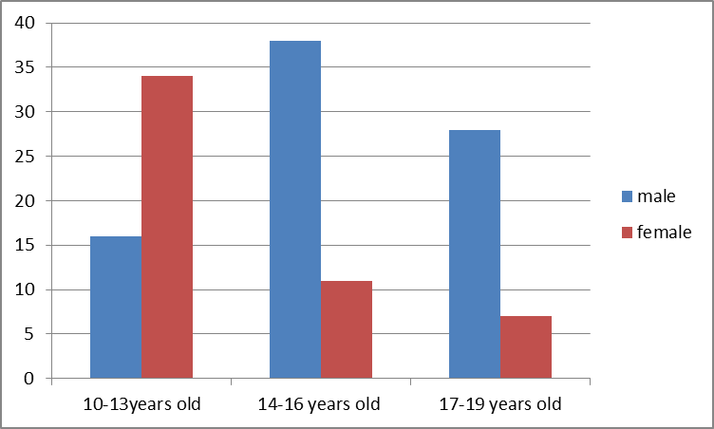
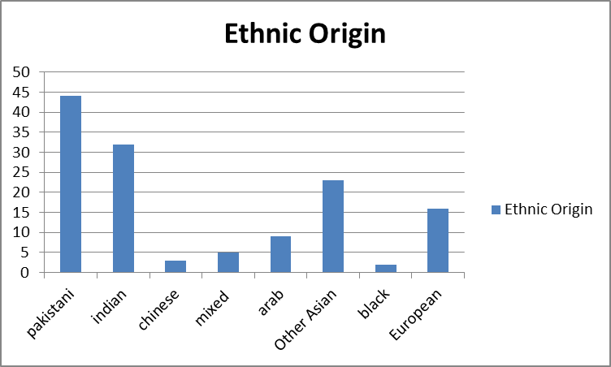

Fig 1 – age/gender breakdown of participants Fig 2 – ethnic breakdown of participants

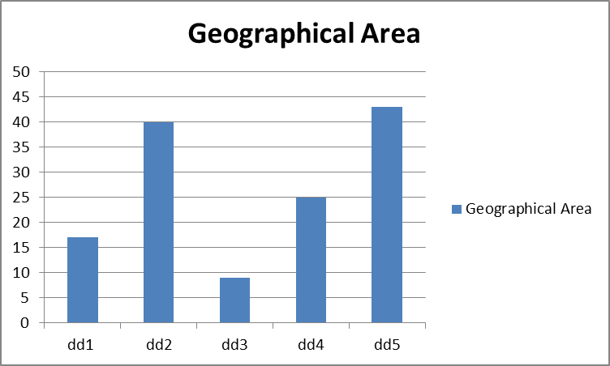
Findings:
- From Fig 1, there were 34 females that participated in the exercise aged 10-12 , 11 in the 14-16 category and only 8 in the 16-19 category
- From Fig 2, the overall ethnic origin breakdown of the participants reflected the ethnic breakdown in the 2001 Census, apart from the Chinese community who were particularly difficult to engage with.

Fig 3 – geographical area of participants

- From Fig 3, there is a varied geographical spread of the minority community but important to note the majority are within the ‘deprived areas’ of Dundee.
- In Census 2001 12% of Tayside’s minority population lived in in the DD1 area and 14% in the DD3 area. In Fig 3, our participation from the DD1 area was also 12% but participation of the DD3 area was only 8%.

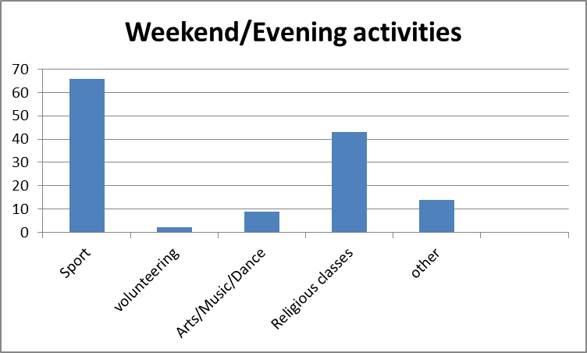
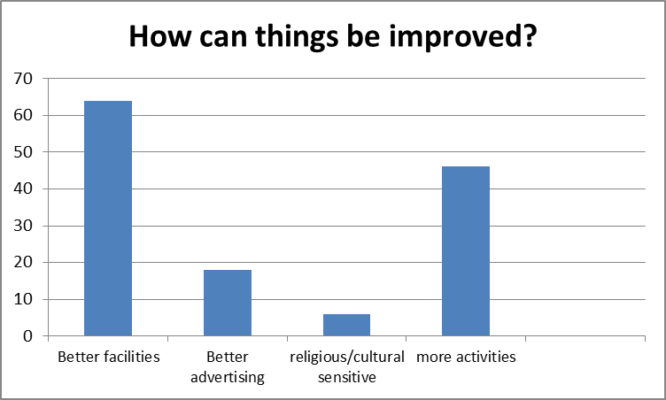

Fig 4 – weekend/evening activities of participants Fig 5 – suggested improvements by participants

Findings:
- 48% of the young people engaged in sports activities (Fig 4). These were primarily self-organised by the young people in either carparks of their local faith centres, sports centres or facilities provided by the BME organisation with which they were affiliated.
- The same number of people (in Fig 5) suggested better facilities would help improve opportunties in sport and other activities. This could mean access to better facilities or improving/creating facilities within their own organisations.
- 33% of the young people engaged in religious classes on a daily basis (Fig 4). This would affect their participation in weekday youth work services provided by the local council and other agencies.
- From Fig 4, there was a low level of engagement with volunteering, arts, music and dance.

3rd Phase – Focus Groups

All the young people that took part in the survey were given the opportunity to participate in a focus group meeting. A total of 22 participants took part in the exercise. The participation in the focus group reflected quite well with the overall participation breakdown in terms of gender and age.

The participants were asked three questions in a group setting; each was given the opportunity to respond. All their responses were collated and sumarised below.

Question 1 Why do older BME girls aged 14+ engage less in youth activity?

There is not enough for young women aged 14+ (although the Yusuf Youth Initiative & Marcara youth clubs were highlighted as exceptions). Generally, the organisations that had regular contact with BME young people provided youth work activities that tended to suit the younger age group. There needs to be more opportunity for leadership development, team building, developing campaigns and volunteering opportunities.

Also, commitments in school tend to be a lot more as you get into the standard grade years. There is less time to engage in social activity.

Question 2 Do you feel you are restricted (culturally/religiously) to engage in mainstream activity/sport?

The young people felt that religion or culture is not a barrier to engaging in youth work activity. However, the activities should be sensitive to certain religious or cultural requirements eg same gendered instructors and participants in the activity. A lot of the activities provided across the city including local authority services have separate programmes for boys and girls. The separation of the genders and same gendered instructors is especially important with swimming.

Question 3 How can things be improved for you to take part in more activities?

The improvements tended to focus around faith centres that don’t have adequate resources to provide for the needs of the young people. There needs to be a mechanism to train young people in the minority community with sports leadership and professional youth work training. There also needs to be a process by which the organisations can be better informed of the local authority facilities and support available to them.

SUMMARY OF FINDINGS AND RECOMMENDED ACTIONS
After consulting with the leaders of organisations and young people, we have put together a summary of the findings and recommended actions for consideration. The findings have been broken down into organisational and young people’s findings with actions accompanying each.

A Organisational Findings :

- A significant proportion of young people from minority communities are involved in language classes, cultural or faith studies every weekday evening. These young people miss the opportunity of engaging in youth work services that are available during those times.
A concern voiced by many of the organisations, in particular the faith centres, was that the activities in which young people from minority communities might participate, should be sensitive to any cultural or religious needs.

- In many other cities of the UK there is an active role by the local authority to promote and celebrate minority communities’ festivals. For example, in Leicester you will find festive lights for each festival across areas that have a large minority population.

- At present the Dundee Carers Centre provides carer support for the BME community. The workers are female and due to cultural or religious sensitivities this can often become a barrier for engagement. The female workers often experience barriers in gaining access to faith centres which are largely male dominated. This can create difficulties in providing support to young male carers.

- Dundee College provides ESOL classes to young people in certain schools across the city. The timings of these classes, and their location, sometimes make it difficult for young people to travel from their school to the class. If there were more ESOL classes located across the city there should be easier access and thus increased participation amongst young people from the minority communities.

- Faith centres and organizations that have regular contact with BME young people may want to organize their own activities. Having access to sports centres, minibus hire and other available resources can only encourage greater involvement.

- In the BME community, for some young women, there may be family pressures regarding the activities in which they can engage. Religious or cultural sensitivities play a larger role in how young women engage in activities. A young person may not admit that this is an issue as it sometimes creates stigma around friends. Nonetheless, it is evident that the organisations that have regular contact with BME young people, have this concern.

- Young people from the Chinese Community in Dundee were particularly difficult to engage with.

Recommended Actions

- Youth Work Providers to offer activities that are sensitive to the religious and cultural needs of all young people. This will be discussed by Dundee's Youth Work Partnership.
- Dundee City Council to recognise and help promote, via the City Council website, the major religious and cultural festivals celebrated by BME communities in Dundee.
- The Dundee Youth Work Partnership to address the question of support for young male carers.
- Dundee's Discover Learning Partnership to review the provision of ESOL classes.
- Further develop strategies for engaging with young people from the chinese community in Dundee.

B Young People’s Findings

- Young people do not have much time to engage in other activities because of school commitments.
- There is a lack of challenging youth work activities for the older age group.
- Young women want activities where they can lead on projects, get involved in campaigns and engage in volunteering.
- Young people are not aware of the mainstream Youth Work programmes available in the city.

Recommended Actions

- Pilot a series of short term schemes to empower BME organisations and faith centres to increase capacity and resources within their own structures.
- Sports development training for a number of 16+ from their respective communities who can then, in turn, provide support for other young people
- The Dundee Youth Work Partnership to engage with local faith/cultural study groups to offer youth work programmes
- Provide capacity building training to community champions to increase youth work provision within their frameworks. The Youth Work Partnership to discuss.
- Promote Youth Work programmes and events through roadshows, posters, websites etc.

AppendiCES
Appendix A

Name of Organisation | Dudhope Centre- Bharatiya Ashram  3 & 5 St Mary Place  Dundee  DD1 5RB
Name of Lead person | Raj Raghu
Contact details | (01382) 220023  ashram1@btconnect.com
How many young people | 40 per week
Ethnic breakdown | 60% Indian, 20 %mix, 20% Scottish
Services | Yoga, Bollywood classes  Sat/Sun 11:30-4:30pm,  Tue 6:30-9pm
Recommendations for mainstream services | Advertising Bharatiya Ashram and other minority activities. Celebrating multi-cultural events (Diwali, Eid etc)

Name of Organisation | Dundee Central Mosque  6 Miln street,  Dundee.  DD1 5BZ
Name of Lead person | Abid Panchbaya
Contact details | 01382 228374  info@dundeecentralmosque.org.uk
How many young people | 139 per week
Ethnic breakdown | 47% Pakistani, 34% Indian, 11% Arab, 8% African
Services | Islamic Studies Class  Monday-Friday 5-7:30pm
Recommendations for mainstream services | More awareness of religious/cultural needs.  Youth work provision on weekends to support local religious group

Name of Organisation | Scottish Islamic Cultural Centre  5 Dura Street,  DUNDEE,  DD4 6RU
Name of Lead person | (Imam) Mohammed Rafiq Habib
Contact details | 01382 226913
How many young people | 80 per week
Ethnic breakdown | 90% Pakistani,5 %African, 5% Bengali
Services | Islamic Studies Class  Monday-Friday 5-7:30pm
Recommendations for mainstream services | More aware of religious/cultural needs.  Extend weekend services for the Mosques

Name of Organisation | Dundee Chinese Community Centre  75A Dens Road  Dundee  DD3 7HY
Name of Lead person | Jenny Chung
Contact details | Jennychung3@hotmail.com  http://www.dundee-tccc.org.uk/
How many young people | 20 per week (20% 10-18 years old)
Ethnic breakdown | 100% Chinese
Services | Learning Chinese & Cultural Activities  Sun 11am-3:30pm
Recommendations for mainstream services | Celebrate cultural activities, Translation services & better inter-minority engagement

Name of Organisation | The Corner  8 Dock Street  Dundee  DD1 3DP
Name of Lead person | Manjeet Gill
Contact details | Telephone: 01382 206060  Facsimilie: 01382 201929  E:mail: office.corner@nhs.net  www.thecorner.co.uk
How many young people | 346 from minority backgrounds
Ethnic breakdown | 24% Asian, 13% European, 8% African, 13% Chinese, other 42%
Services | Advice, Support and information
Recommendations for mainstream services | N/A

Name of Organisation | Tayside Hindu Cultural Community Centre  10 Taylors Lane  Dundee  DD2 1AQ
Name of Lead person | Naina Penman
Contact details | 01382 669652
How many young people | 20 /weekly
Ethnic breakdown | 80% Indian, 20% Pakistani
Services | Religious & Cultural classes
Recommendations for mainstream services | More advertising of ethnic events,

Name of Organisation | Tayside Islamic and Cultural  Education Society  96A Victoria Road  Dundee  DD1 2N
Name of Lead person | (Imam ) Mohammed Ajaz
Contact details | 01382 224817
How many young people | 55
Ethnic breakdown | 90% Pakistani, 7% African, 3% Bengali
Services | Religious Classes
Recommendations for mainstream services | Weekend activities, religious provision

NAme of Organisation | Dundee College – ESOL Class
Name of Lead person | Berenice Hunter
Contact details | b.hunter@dundeecollege@ac.uk
How many young people | 25 young people (14-16)
Ethnic breakdown | 70% Polish, 30% Indian sub-continents/Arab
Services | ESOL classes
Recommendations for mainstream services | ESOL in more locations. Fluency in English may support youth work

Name of Organisation | Dundee Carers Centre
Name of Lead person | Sofia Rizwan
Contact details | 01382 200442
How many young people | 70
Ethnic breakdown | 99% South Asian, 99% Muslim
Services | Culturally/ religiously sensitive (prayer facilities, single sex groups, halal food etc)  Offer classes on stress management, fire safety, first aid, yoga and energy advice.  Wednesday 10:30am- 1pm  Friday 10:30am-1pm
Recommendations for mainstream services | More sensitive to the needs of BME young people, cultural awareness training  Gap for male carers with religiously sensitive needs
Name of Organisation |  | Yusuf Youth Initiative  34 Bellfield Street, Dundee  DD1 5HZ
Name of Lead person |  | Faisal Hussein
Contact details |  | 01382 226691
How many young people |  | 70
Ethnic breakdown |  | 30% Pakistani, 30% Indian, 20% Arab, 20% African and other
Services |  | Leadership programme for 10-19 year olds.  Offer sports accreditation  Social Action projects  Integration projects  Friday 7:30pm-8:30pm (Girls)  Saturday 3pm-6pm (boys – monthly)
Recommendations for mainstream services |  | - Empower young people from minority communities with leadership training  - Encourage greater volunteering in the minority community  - Increase capacity of faith centres and organisations that work with young people

Appendix B

1. Personal details. Are you..
10-13 years old [ ] 14-16 years old [ ] 17-19 years old [ ]

2. Are you? Male [ ] Female [ ]

3. What is your nationality?
Pakistani [ ] Indian [ ] Chinese [ ] Mixed background [ ] Arab [ ] Other South Asian [ ] Black [ ] Other (please specify) ………………………

4. Which area postcode do you live in?
DD1 [ ] DD2 [ ] DD3 [ ] DD4 [ ] DD5 [ ]

5. What do you do in the evenings or weekend?
Sport [ ] Volunteering [ ] Arts/Music/dance [ ] Religous classes [ ] Any other out of school activity (please specify) ……………………………………………………

6. What is the name of the place (or area) you do the activities? .................................................

7. What kind of stuff would you like to do in your spare time? ………………………………………………………...........................................................................................
……………………………………………………………………………………………………………………………………………………

8. How can youth activities be improved?
better facilities [ ] better advertising [ ] Religious/culture sensitive [ ] more activities [ ] (please specify)
…………………………………………………………………………………………………………………………………………………………………………………………………………………………………………………………………………………………………………

9. Any other comments .....................................................................................................................................…………………………………………………………………………………………………………………………………………………………………………..……………………………………………………………………………………………………………………………………………………..

10. If you would like to be kept up to date on the progress of the project add your email address below;
..........................................................................................................................................................................................................................................................................................................

