APPLICATION FOR USE

PUBLIC PROCESSION AND USE OF CITY SQUARE

CHECKLIST

 | CHECKLIST |  | APPLICANT’S CHECK | FOR OFFICE USE
1. | Have questions 1 to 7 been completed? |  | Yes/No | Yes/No
2. | Is the contact details completed  i.e. e-mail address and telephone number? |  | Yes/No | Yes/No
3. | Is the application form signed and dated? |  | Yes/No | Yes/No
4. | Is a copy of the current Public Liability Insurance attached? |  | Yes/No | Yes/No
5. | Is a site plan attached? |  | Yes/No | Yes/No
6. | Have you read the Privacy Notice? |  | Yes/No | Yes/No
6. | Is a TTRO Required? If you are looking close any roads you will need to speak to the Road Department email addresses as follows : michael.cobb@dundeecity.gov.uk or andy.scrimgeour@dundeecity.gov.uk a fee is required. DCC Roads to then contact Tayside Ops planning mailbox to enquire if procession requires police involvement / escort / traffic control. |  | Yes/No | Yes No

IT IS REQUESTED EARLY ENGAGEMENT WITH DCC ROADS DEPT TO DISCUSS ADEQUATE TRAFFIC MANAGEMENT /CONTROL /ROAD CLOSURES IF WALKING ON A PUBLIC ROAD. DCC WILL THEN FORWARD YOUR NOTIFICATION TO POLICE SCOTLAND. PLEASE BE AWARE THAT POLICE SCOTLAND MAY NOT BE ABLE TO PROVIDE POLICE OFFICERS FOR ROAD CLOSURES. IT WILL BE THE RESPONSIBILITY OF THE ORGANISER TO MAKE NECESSARY ROAD CLOSURE ARRANGEMENTS TO MAXIMISE THE SAFETY OF PROCESSION PARTICIPANTS AND OTHER ROAD USERS.

COMMENTS

PLEASE NOTE - | APPLICATION TO BE LODGED NO LATER THAN 14 DAYS AFTER BOOKING MADE OR THE BOOKING WILL BE CANCELLED.



NOTICE OF PROPOSAL TO HOLD A PUBLIC PROCESSION AND USE OF CITY SQUARE

Important notice - As the organiser of your event you should give us at least 28 days' notice of your intention to hold a procession. If you cannot provide the notice needed, you should contact Licensing Office to apply for an exemption. We can only make an exemption in exceptional circumstances.

You should read the attached code of conduct and fill in all sections of the form and:

- Email the form to licensing.board@dundeecity.gov.uk or post to the Licensing Office, 21 City Square, Dundee DD1 3BY.

- keep a copy for yourself.

- we will make sure that we give a copy of your notification to the police.

- we may ask you to fill in and return a risk-assessment form with this notification form. We will let you know if this is necessary.

- you must bring your copy of this form, along with any risk-assessment form which we may ask you to fill in, to any meeting that we may hold to discuss your notification in more detail.

Please provide the following details.

1. | Your contact details
 | Name: | ...............................................................................................................................
 | Address: | ...............................................................................................................................  ...............................................................................................................................
 | Postcode: | ..............................................................
 | Phone number: |  | ...................................................................
 | E-mail address: |  | ........................................................................................................................
2. | Name of Organisation or band: |  |  | .......................................................................................
3. | Date and start time of procession: |  |  | .......................................................................................
4. | Reason for procession: |  |  | .......................................................................................

5. | The proposed route: |  |  |  |  | .....................................................................................  .....................................................................................  .....................................................................................  .....................................................................................  .....................................................................................  .....................................................................................
6. | Number of people expected to take part: |  |  |  |  | .....................................................................................
7. | Please provide details of the arrangements for controlling the event: |  |  |  |  | .....................................................................................  .....................................................................................  .....................................................................................
 | (Please continue on a separate sheet, if you need to).
8. | Number of stewards attending ...................................... Number of buses or coaches .........................
9. | What parking arrangements have you made for the buses/coaches? |  |  |  |  |  | ......................................................................................  .....................................................................................  ......................................................................................
10. | Names of any bands and names of each band member who will be taking responsibility for the bands. The named band member must be present on the day and must identify themselves to the police.
 | Name of Bands |  |  | Band A | ...............................................................................
 |  |  |  | Band B | ...............................................................................
 |  |  |  | Band C | ...............................................................................
 | Name of responsible band member for |  |  | Band A | ...............................................................................
 |  |  |  | Band B | ...............................................................................
 |  |  |  | Band C | ...............................................................................
 | (Please fill on a separate sheet, if necessary).
11 | Please provide any extra information about the procession which you think may be relevant (eg reasons why it is not possible for this procession to be combined with other similar ones).
12 | Please provide details about the return procession (if this applies).
13. | CITY SQUARE
 | (1) | No of Stalls  (See Note 1 overleaf for access issues).
 | (2) | Who is providing the stalls?
 | (3) | (a) | Are there any fairground/carnival type  rides? |  |  |  |  | YES/NO  (Delete as appropriate)
 |  |  | If yes give details |  |  |  |  | ...................................................................
 |  | (b) | Are there any vehicles involved? |  |  |  |  | YES/NO  (Delete as appropriate)
 |  |  | If yes give weight and size of each vehicle (laden and unladen). |  |  |  |  | ...................................................................
 | (Please note vehicles are not permitted on City Square (Display Area 2). Vehicles will require to be sited in the "D" area. (Display Area 1) Please read notes on Page 4 carefully.)

 | (4) | Estimated time of departure from City Square. | ................................................................

Licensing Privacy Notice

The information you have provided on this application form, and from supporting documentary evidence – where applicable – will be used by Dundee City Council (the "data controller") for the purposes of the General Data Protection Regulation and the Data Protection Act 2018 in order to process your licensing application.

The Council may check information provided by you, or information about you provided by a third party such as NHS Tayside, Scottish Fire and Rescue Service, Scottish Ambulance Service and Police Scotland with other information held by us. We may also get information from those third parties or share your information with them in order to check its accuracy, prevent or detect crime, protect public funds or where required by law.

In order to process your application, we will share your information in accordance with the Civic Government (Scotland) Act 1982, other licensing legislation and with relevant internal services of Dundee City Council.

Please note that you should read this service specific Privacy Notice in conjunction with the Council's Full Privacy Statement which is accessible on the Council's website at: www.dundeecity.gov.uk/privacy

I declare that the particulars given by me on this form are correct to the best of my knowledge and belief. I authorise the use of all information which I have provided for the above purposes. I hereby make application to Dundee City Council for the grant or renewal of the licence applied for.

Your signature ...................................................................... Date ...................................................

Please return this form to:

Licensing.board@dundeecity.gov.uk or hand deliver to 21 City Square, Dundee, DD1 3BY.
NOTES FOR USERS

1. Vehicles are NOT permitted on City Square (Display Area 2). Vehicles can be accommodated in the 'D' Area (Display Area 1). Vehicular access is from the east (Castle Street) and all vehicles must leave north via Reform Street. Please note that due to road traffic regulations all vehicles must be on site prior to 11.00 a.m. and may not leave until after 4.00 p.m. Vehicles which are not part of the event are not permitted to remain on site.

2. Any costs incurred in repairing/cleaning surface areas will be recovered from user.

3. Access and egress to the buildings surrounding the City Square must be kept clear for use by emergency services as outlined on the attached plan. (Hatched area. The area hatched in red on the plan must be kept clear at all times).

4. Organisers must comply with any instructions issued by on-duty Police Officers or any Authorised Officer of the City Council.

5. No unnecessary vehicles to remain on site.

6. If cabling is to be used across pedestrian areas, a suitable safety covering must be used. Any equipment must be tested for the day of use and must be outdoor HOFR/BS7919 cable 16 amp.

7. The Council reserve the right to withdraw consent immediately if noise levels become excessive.

8. Access to electricity is not available.

DEPENDING ON THE PARTICULAR EVENT YOU MAY BE REQUIRED TO SUBMIT THE FOLLOWING

- Event Risk Assessment
- Event Safety Manual
- Event Health and Safety Plan
- Current Certificate of Insurance for Public Liability (minimum of £5,000,000)
- Copy of the organisations latest accounts
- Copy of the organisations current membership and details of Office Bearers
- A note of any OSCR Registrations (or English equivalent)

PLEASE NOTE THAT ALL NECESSARY PAPERWORK AND APPROVALS FROM COUNCIL DEPARTMENTS OR OTHER ORGANISATIONS IN CONNECTION WITH THE USE OF CITY SQUARE MUST BE IN PLACE 7 DAYS BEFORE THE EVENT IS TO TAKE PLACE OR THE APPLICATION WILL BE REFUSED.

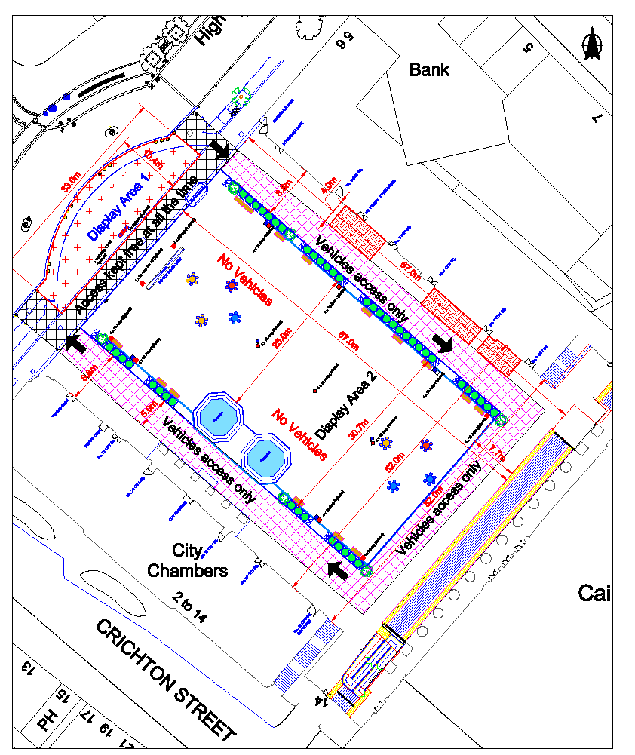

CODE OF CONDUCT

PARADES/PROCESSIONS

All organisers should:

- provide 28 days notice to the Police and the Council of the intention to hold a procession;

- give notification as early as possible in those cases where a series of similar processions is proposed;

- co-operate with the Council and the Police from the time of submission of the notification of a procession until the procession disperses;

- identify himself/herself to the Police Officer (if present) in charge at the commencement of the procession;

- ensure that all participants have been informed of any conditions imposed on the procession (change to timing, change to route etc);

- ensure anyone under the influence of alcohol or drugs is not allowed to participate;

- ensure an appropriate ratio of stewards or marshals to participants (one to ten) and that all stewards:

are briefed by organisers and given guidance/instruction on their role prior to the procession;

carry proof of status;

co-operate with the Police if required;

are highly visible and easily identifiable;

conduct themselves in a proper manner;

ensure that participants comply with directions regarding their own public safety and that of the public;

- ensure that, wherever possible, processions follow main roads, rather than going through residential housing developments;

- ensure that all participants do not march more than four abreast, keeping to the near or left hand side of the street except on one-way streets where they will keep to the right side;

- ensure that a suitable traffic management plan is in place guaranteeing safe passage for traffic and pedestrians which may involve a traffic management company, stewarding plan (traffic management trained stewards or parade escort stewards) and Police.

- ensure that the procession is split into sections in order to avoid serious dislocation of traffic and to facilitate the crossing of pedestrians who have a right of free access and passage to or through any public area;

- ensure that all playing of music ceases when approaching and passing places of worship while services are in progress, as instructed by stewards or the Police;

- ensure all participants disperse as soon as the procession concludes unless an organised event is to follow;

- ensure that the behaviour or participants could not reasonably be perceived as being deliberately aggressive (ie threatening, abusive, homophobic, sectarian or racist);

- accept that he/she is responsible for the behaviour of all participants, including bands where appropriate, (as well as followers) and for ensuring general compliance with the Council's policy on public processions and Police instructions;

- note that the conditions of Section 62 of the Control of Pollution Act 1974 in relation to the use of loudspeakers shall be observed;

- note that the terms of the Public Order Act 1986 in relation to the prohibition of the wearing of uniforms signifying association with any political organisations etc shall be observed;

- note that the terms of the Dundee City Council (Prohibition of the consumption of Alcohol) Byelaws 1999, in relation to the prohibition of the consumption of alcohol by any person in a designated place shall be observed;

- note that the Council may take into account any public disorder, anti-social behaviour or damage to property resulting from a specific procession if notification is received from the organiser for a similar march.

All participants in processions should:

- behave with due regard for the rights, traditions and feelings for others in the vicinity of the procession, particularly in areas where there has previously been public disorder around processions;

- behave with due respect at "sensitive" areas such as places of worship;

- refrain from using words or behaviour which could reasonably be perceived as being deliberately aggressive (ie threatening, abusive, homophobic, sectarian, or racist);

- obey the lawful direction of procession organisers, stewards and the Police at all times;

- keep to the designated route as directed by the organiser/stewards or Police;

- refrain from consuming alcohol or drugs prior to or during the procession;

- not display flags relating to proscribed organisations or which are likely to cause offence;

- disperse in good order as soon as the procession concludes.

