Dundee City Council

Budget Consultation Survey

jill brash

Public Service Improvement Framework Assessment 2017

jill brash

January 2019
Contents
Background 2
Questions 3
Results 4
Appendix – Full Results 7

Background
The budget consultation survey was made available via the Council’s internet site during the months of November and December 2018, this was publicised in the press and via DCC social media networks.
A total of 1171 completed responses were received in the time it was live, the responses of these are outlined fully in the appendix tables of this report.
90% of those who responded to the survey were residents of Dundee, 45% of respondents worked in Dundee and this may include people who live out with the area.
Q1: We would like to know a little about you, are you;
Resident of Dundee | 90.3%
Work in Dundee | 45.0%
Other | 1.0%

The age distribution of respondents was reasonably balanced which is encouraging when using an open consultation, 63% of respondents were under the age of 50 and 36% aged 50 and over.
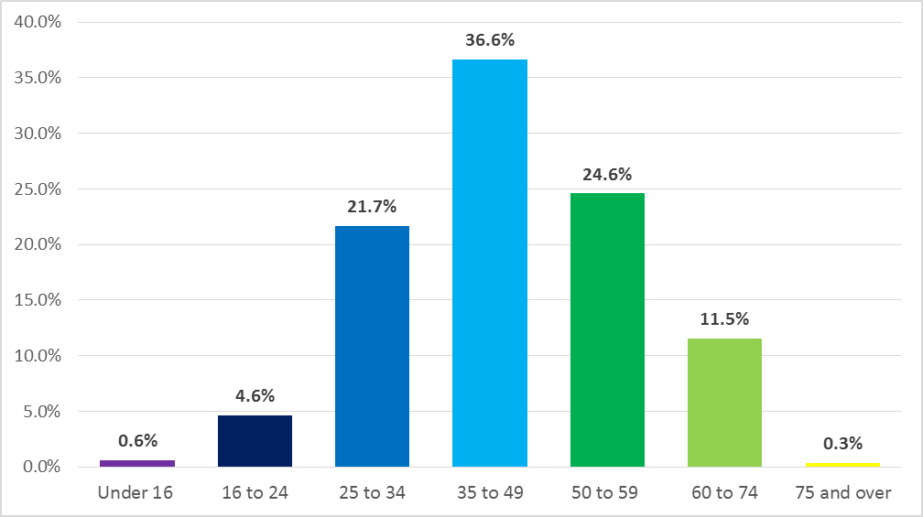

Respondents were asked if this was the first time they had participated in one of the Councils consultations.
Q3: Is this the first time that you have taken part in one of our consultations? | Percentage
Yes | 67.4%
No | 32.6%
For 67% of respondents this was the first time they had taken part in a DCC Council consultation, 32% of people had taken part in a consultation before. They were asked to indicate the consultation which they had taken part in previously, the most common exercise being the Dundee Decides consultation followed by the Council house rent setting exercise.
If you answered "no" to the above, can you tell us what you have previously engaged in? | Percentage
Dundee Decides | 91.6%
Council house rent setting | 4.2%
Other | 4.2%
“Other”
Save Menzieshill High School
Engage Dundee
Menzieshill school consultation
Twenty's Plenty
Local Consultative Budgeting Survey

Questions
The survey asked a number of questions based on 15 areas across the Council, 5 themes and 10 council services. Respondents were asked to rate the relative importance (within a budget setting context) and the level of importance that they felt towards these on a scale of 1 to 10. 1 being least important and 10 being most important. Respondents were asked to rate each them and service in this way.
The identified themes and services were;
Theme
Health Care and Wellbeing
Building Stronger Communities
Children and Families
Fair Work and Enterprise
Community Safety and Justice
Education (nursery, primary and secondary)
Services
Older People's Services
Planning and Job Creation
Services for people with disabilities
Housing and Homelessness
Work and Enterprise
Waste Collection and Recycling
Roads Maintenance and Street Lighting
Parks and Open Spaces
Street Cleaning
Leisure and Culture

Results

The graph below indicates the level of importance respondents felt towards each theme, Health Care and Wellbeing, Children and Families and Community Safety and Justice all had an average of
over 8 in the scale of importance. Building Stronger Communities had the lowest average score of 7.6 on the scale of importance. The average figure for each theme is shown in brackets.

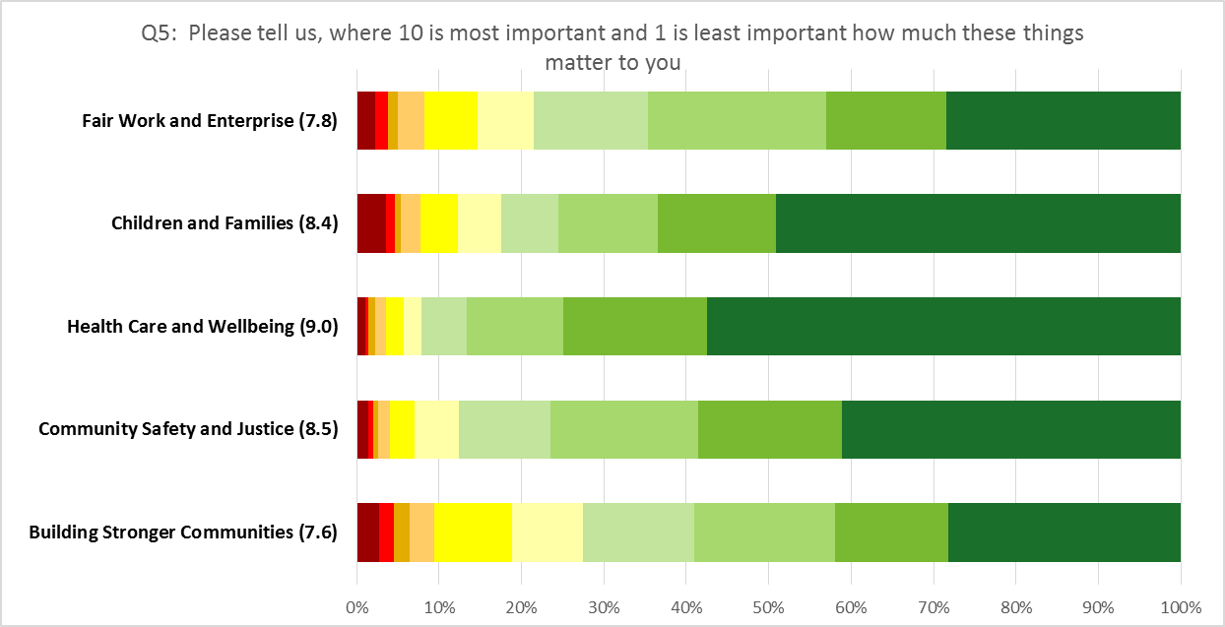

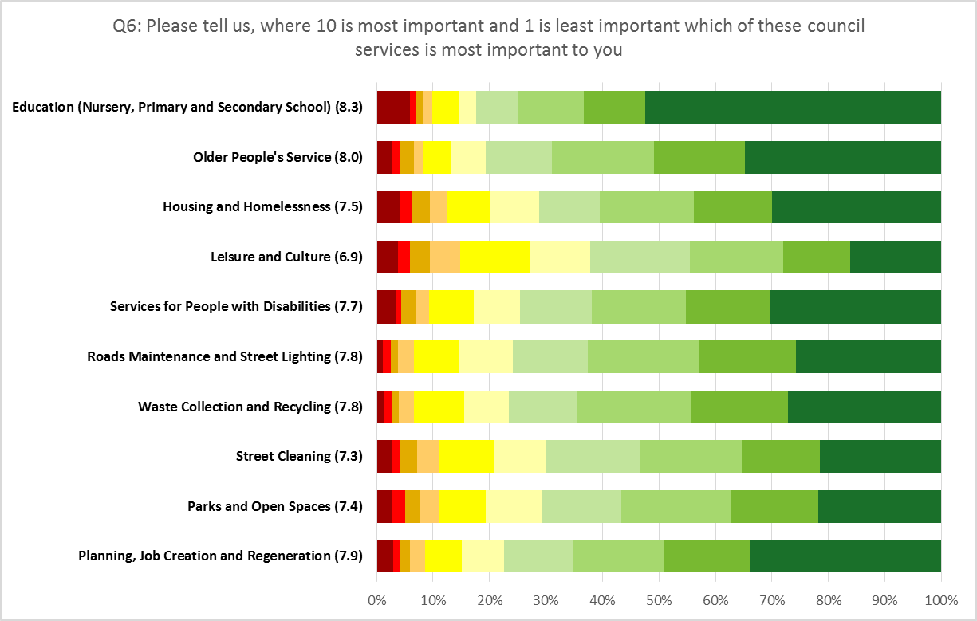
In relation to specific council services, Education Services and Older People’s services both scored averages of over 8 in the scale of importance with Leisure and Culture having a lower average of 6.9.

Respondents were asked what percentage change in Council Tax was preferable, the survey highlighted that a 1% change would be equal to an increase of 4p a day and a 3% rise equal to 11p a day. 65% of respondents stated they would be comfortable to see an increase in Council Tax, with 34.8% stating they would rather see no change. 8.4% indicated a preference for a rise of more than 3%. 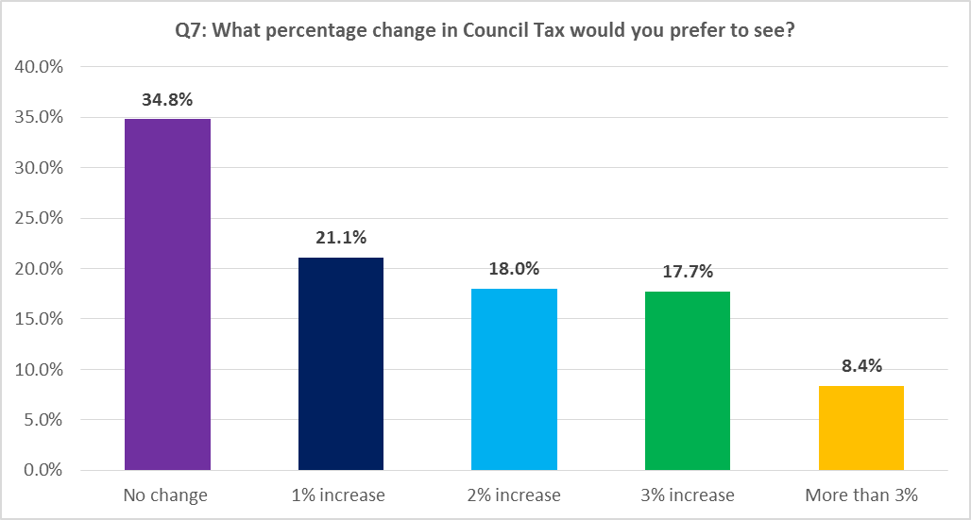
Q7: What percentage change in Council Tax would you prefer to see? | Percentage
No change | 34.8%
1% increase | 21.1%
2% increase | 18.0%
3% increase | 17.7%
More than 3% | 8.4%
N = 1172
Respondents were also asked to rate their opinion on a number of statements in relation to how the Council could review its services and property in order to save money, on the scoring scale 1 related to “totally disagree” and 10 “totally agree”, these statements were;
- The council should review how it charges for services, even if this means brining new or increasing charges by more than inflation
- The council should reduce or stop some non-statutory services to protect other services
- The council should reduce or stop the grants that it gives to other organisations
- The council should change or reduce opening hours for some public services and buildings
- Some buildings should be closed completely
- The council should continue to sell the property it no longer has a use for
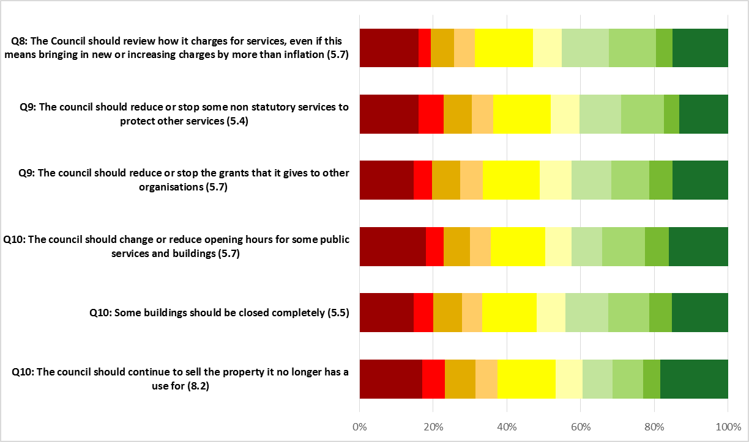
The statement that “the council should continue to sell the property it no longer has a use for” had the highest average score on the scale of agreement of 8.2, all other statements had a similar score of just over 5. The average figures are shown in the brackets below.

Appendix – Full Results

Percentage of those who strongly agreed (number 10 option on the scale of importance) that these services were most important to them
Service/Theme Area | %
Health Care and Wellbeing | 57.5
Education | 52.5
Children and Families | 49.1
Community Safety and Justice | 41.1
Older People's Services | 34.8
Planning and Job Creation | 33.8
Services for people with disabilities | 30.4
Housing and Homelessness | 30.0
Work and Enterprise | 28.4
Building Stronger Communities | 28.2
Waste Collection and Recycling | 27.1
Roads Maintenance and Street Lighting | 25.8
Parks and Open Spaces | 21.8
Street Cleaning | 21.5
Leisure and Culture | 16.2

Percentage of those who strongly disagreed (number 1 option on scale of importance) that
these services/Themes were most important to them
Service Area | %
Leisure and Culture | 14.8
Housing and Homelessness | 12.5
Parks and Open Spaces | 10.9
Street Cleaning | 10.9
Education | 9.9
Services for people with disabilities | 9.3
Building Stronger Communities | 9.3
Planning and Job Creation | 8.7
Older People's Services | 8.3
Work and Enterprise | 8.3
Children and Families | 7.8
Waste Collection and Recycling | 6.7
Roads Maintenance and Street Lighting | 6.7
Community Safety and Justice | 4.1
Health Care and Wellbeing | 3.6

Question 5
Please tell us, where 10 is most important and 1 is least important how much these things matter to you.
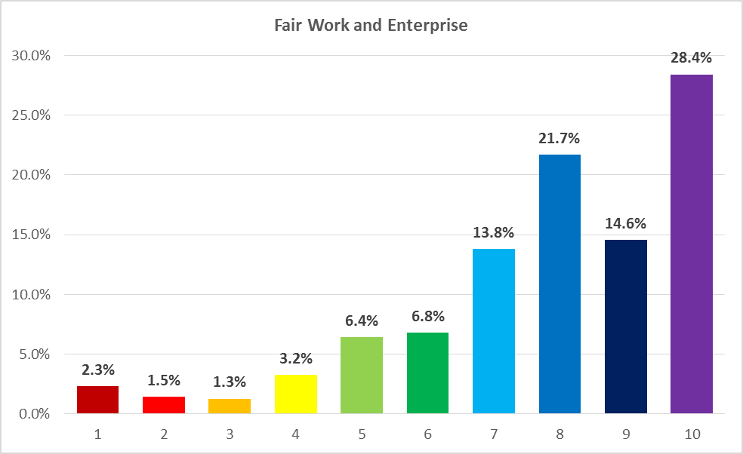
Q5: Please tell us, where 10 is most important and 1 is least important how much these things matter to you - Fair Work and Enterprise | Percentage
1 | 2.3%
2 | 1.5%
3 | 1.3%
4 | 3.2%
5 | 6.4%
6 | 6.8%
7 | 13.8%
8 | 21.7%
9 | 14.6%
10 | 28.4%
N = 1172

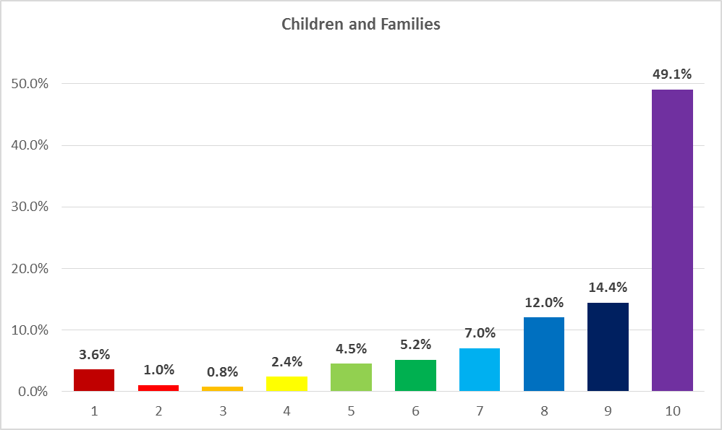
Q5: Please tell us, where 10 is most important and 1 is least important how much these things matter to you - Children and Families | Percentage
1 | 3.6%
2 | 1.0%
3 | 0.8%
4 | 2.4%
5 | 4.5%
6 | 5.2%
7 | 7.0%
8 | 12.0%
9 | 14.4%
10 | 49.1%
N = 1172

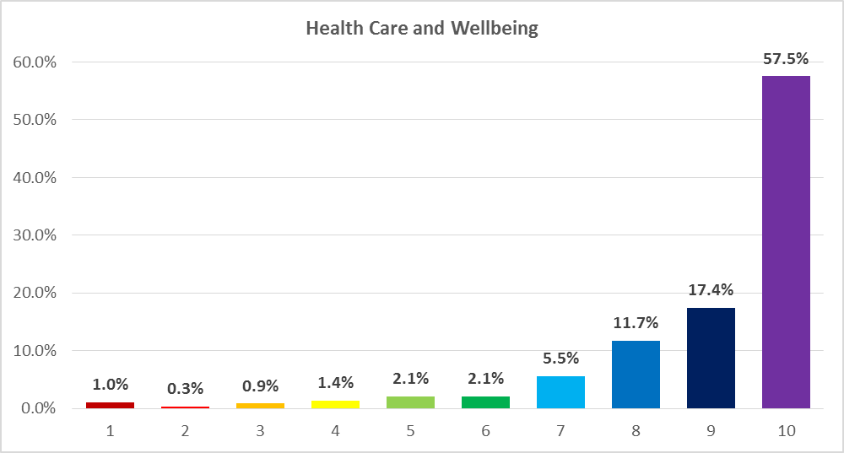
Q5: Please tell us, where 10 is most important and 1 is least important how much these things matter to you - Health Care and Wellbeing | Percentage
1 | 1.0%
2 | 0.3%
3 | 0.9%
4 | 1.4%
5 | 2.1%
6 | 2.1%
7 | 5.5%
8 | 11.7%
9 | 17.4%
10 | 57.5%
N = 1172

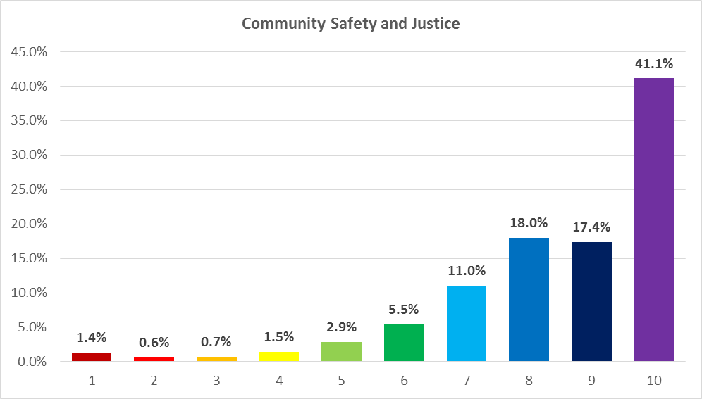
Q5: Please tell us, where 10 is most important and 1 is least important how much these things matter to you - Community Safety and Justice | Percentage
1 | 1.4%
2 | 0.6%
3 | 0.7%
4 | 1.5%
5 | 2.9%
6 | 5.5%
7 | 11.0%
8 | 18.0%
9 | 17.4%
10 | 41.1%
N = 1172

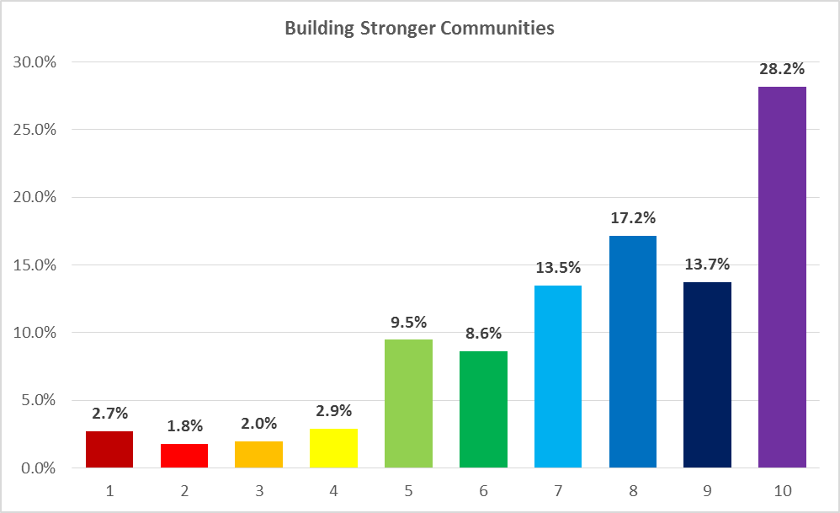
Q5: Please tell us, where 10 is most important and 1 is least important how much these things matter to you - Building Stronger Communities | Percentage
1 | 2.7%
2 | 1.8%
3 | 2.0%
4 | 2.9%
5 | 9.5%
6 | 8.6%
7 | 13.5%
8 | 17.2%
9 | 13.7%
10 | 28.2%
N = 1172

Question 6
Please tell us, where 10 is most important and 1 is least important which of these council services is most important to you
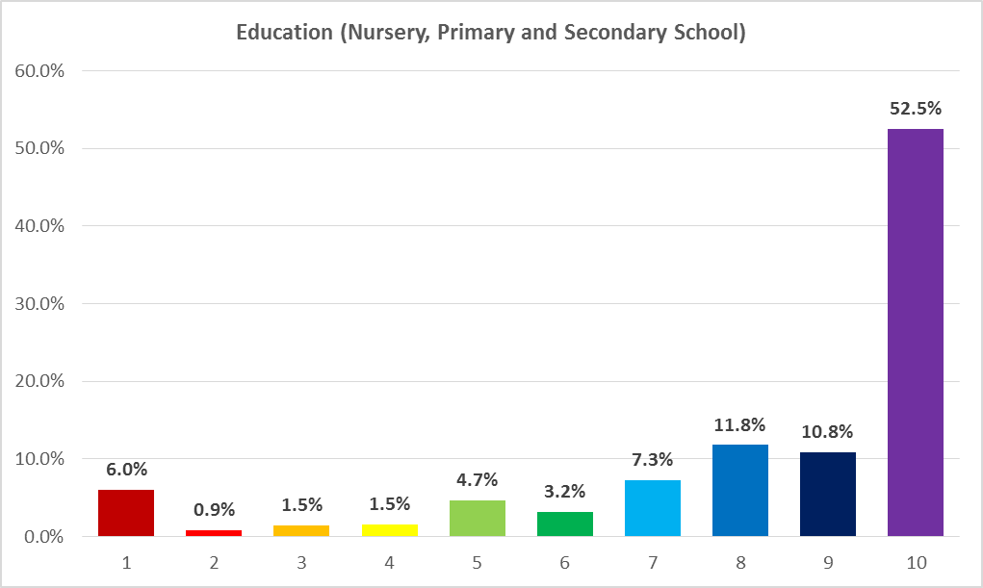
Q6: Please tell us, where 10 is most important and 1 is least important which of these council services is most important to you - Education (nursery, primary and secondary school) | Percentage
1 | 6.0%
2 | 0.9%
3 | 1.5%
4 | 1.5%
5 | 4.7%
6 | 3.2%
7 | 7.3%
8 | 11.8%
9 | 10.8%
10 | 52.5%
N = 1172

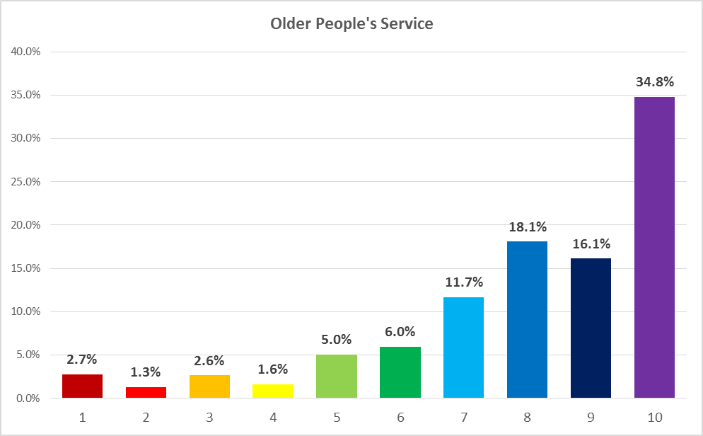
Q6: Please tell us, where 10 is most important and 1 is least important which of these council services is most important to you - Older people's services | Percentage
1 | 2.7%
2 | 1.3%
3 | 2.6%
4 | 1.6%
5 | 5.0%
6 | 6.0%
7 | 11.7%
8 | 18.1%
9 | 16.1%
10 | 34.8%
N = 1172

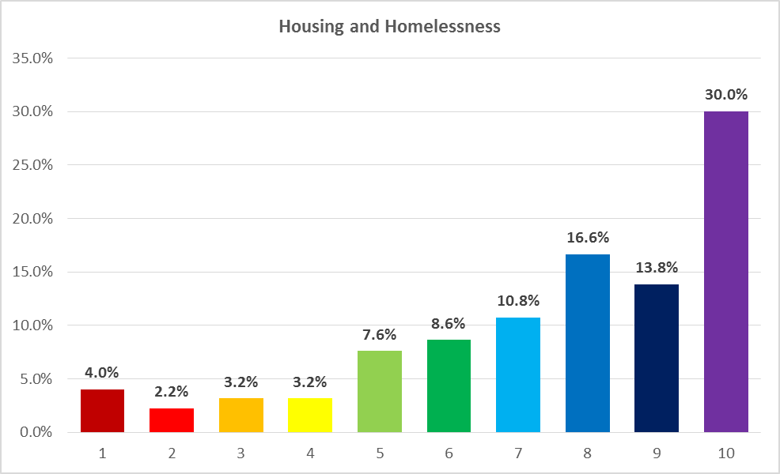
Q6: Please tell us, where 10 is most important and 1 is least important which of these council services is most important to you - Housing and Homelessness | Percentage
1 | 4.0%
2 | 2.2%
3 | 3.2%
4 | 3.2%
5 | 7.6%
6 | 8.6%
7 | 10.8%
8 | 16.6%
9 | 13.8%
10 | 30.0%
N = 1172

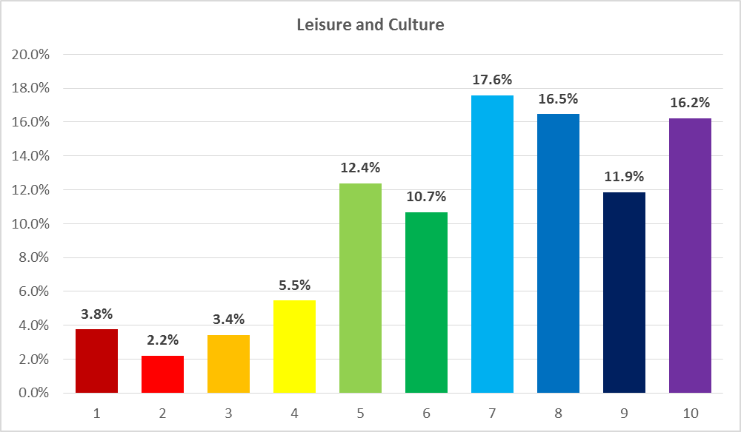
Q6: Please tell us, where 10 is most important and 1 is least important which of these council services is most important to you  [Leisure and Culture] | Percentage
1 | 3.8%
2 | 2.2%
3 | 3.4%
4 | 5.5%
5 | 12.4%
6 | 10.7%
7 | 17.6%
8 | 16.5%
9 | 11.9%
10 | 16.2%
N = 1172

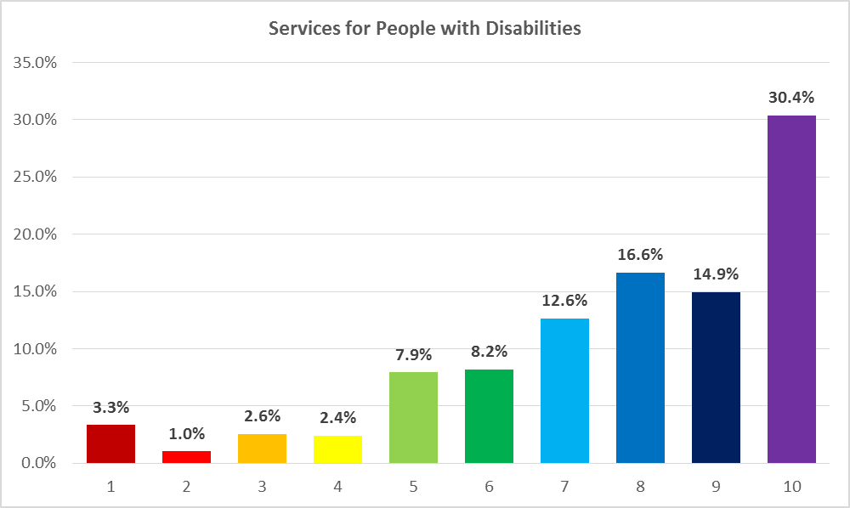
Q6: Please tell us, where 10 is most important and 1 is least important which of these council services is most important to you - Services for people with disabilities | Percentage
1 | 3.3%
2 | 1.0%
3 | 2.6%
4 | 2.4%
5 | 7.9%
6 | 8.2%
7 | 12.6%
8 | 16.6%
9 | 14.9%
10 | 30.4%
N = 1172

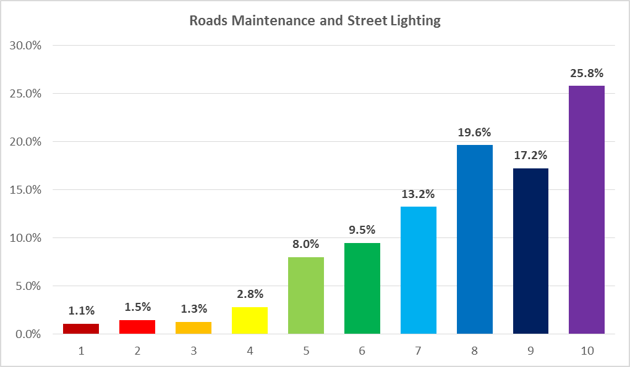
Q6: Please tell us, where 10 is most important and 1 is least important which of these council services is most important to you - Roads maintenance and street lighting | Percentage
1 | 1.1%
2 | 1.5%
3 | 1.3%
4 | 2.8%
5 | 8.0%
6 | 9.5%
7 | 13.2%
8 | 19.6%
9 | 17.2%
10 | 25.8%
N = 1172

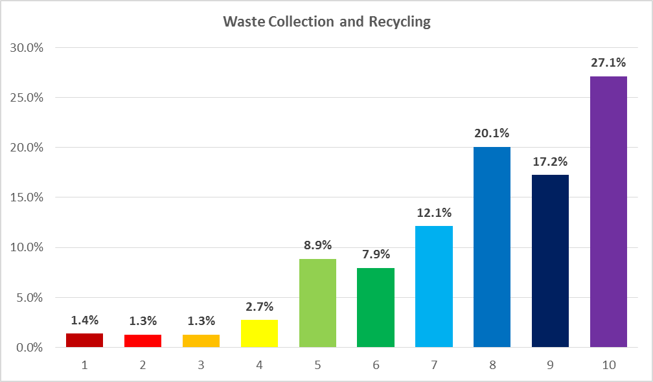
Q6: Please tell us, where 10 is most important and 1 is least important which of these council services is most important to you - Waste collection and recycling | Percentage
1 | 1.4%
2 | 1.3%
3 | 1.3%
4 | 2.7%
5 | 8.9%
6 | 7.9%
7 | 12.1%
8 | 20.1%
9 | 17.2%
10 | 27.1%
N = 1172

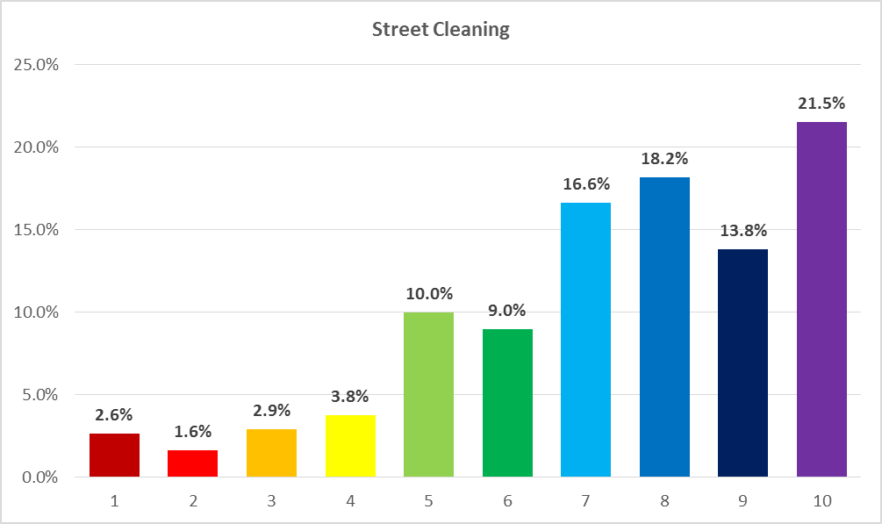
Q6: Please tell us, where 10 is most important and 1 is least important which of these council services is most important to you - Street cleaning | Percentage
1 | 2.6%
2 | 1.6%
3 | 2.9%
4 | 3.8%
5 | 10.0%
6 | 9.0%
7 | 16.6%
8 | 18.2%
9 | 13.8%
10 | 21.5%
N = 1172

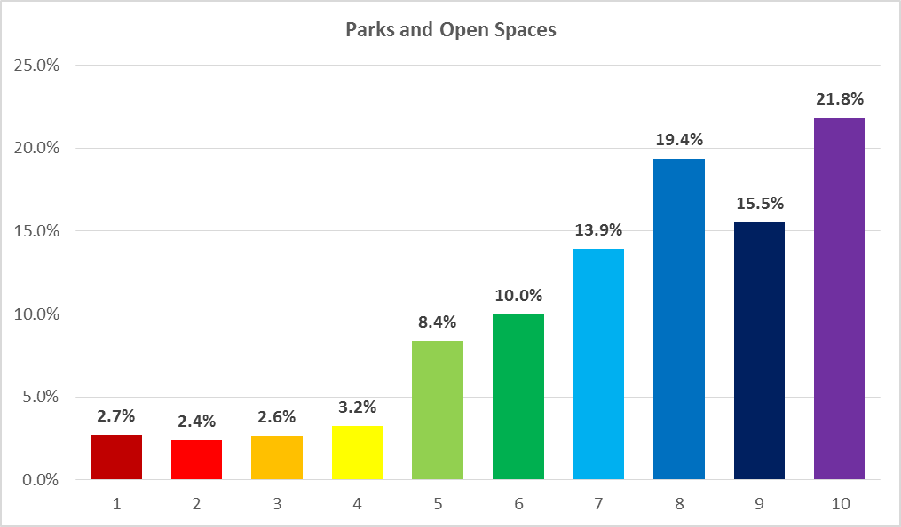
Q6: Please tell us, where 10 is most important and 1 is least important which of these council services is most important to you - Parks and open spaces | Percentage
1 | 2.7%
2 | 2.4%
3 | 2.6%
4 | 3.2%
5 | 8.4%
6 | 10.0%
7 | 13.9%
8 | 19.4%
9 | 15.5%
10 | 21.8%
N = 1172

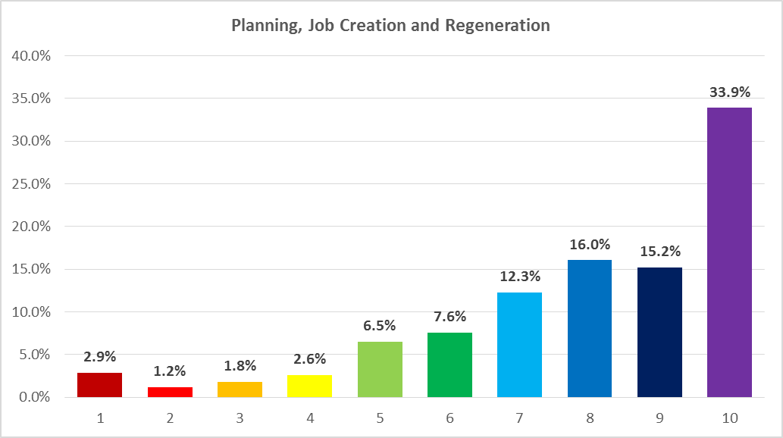
Q6: Please tell us, where 10 is most important and 1 is least important which of these council services is most important to you - Planning, job creation and regeneration | Percentage
1 | 2.9%
2 | 1.2%
3 | 1.8%
4 | 2.6%
5 | 6.5%
6 | 7.6%
7 | 12.3%
8 | 16.0%
9 | 15.2%
10 | 33.9%
N = 1172

Question 7
Council Tax is about 11% of the council's income. What percentage change in Council Tax would you prefer to see? A 1% rise in Band D Council Tax is equivalent to around 4 pence a day, a 3% increase is around 11 pence a day.
Q7: What percentage change in Council Tax would you prefer to see? | Percentage
No change | 34.8%
1% increase | 21.1%
2% increase | 18.0%
3% increase | 17.7%
More than 3% | 8.4%
N = 1172

Question 8
As well as maintaining and improving services by raising more through increasing the Council Tax the council also charges for some services. Where 10 is completely agree and 1 is totally disagree tell us how much you agree with the following statement.
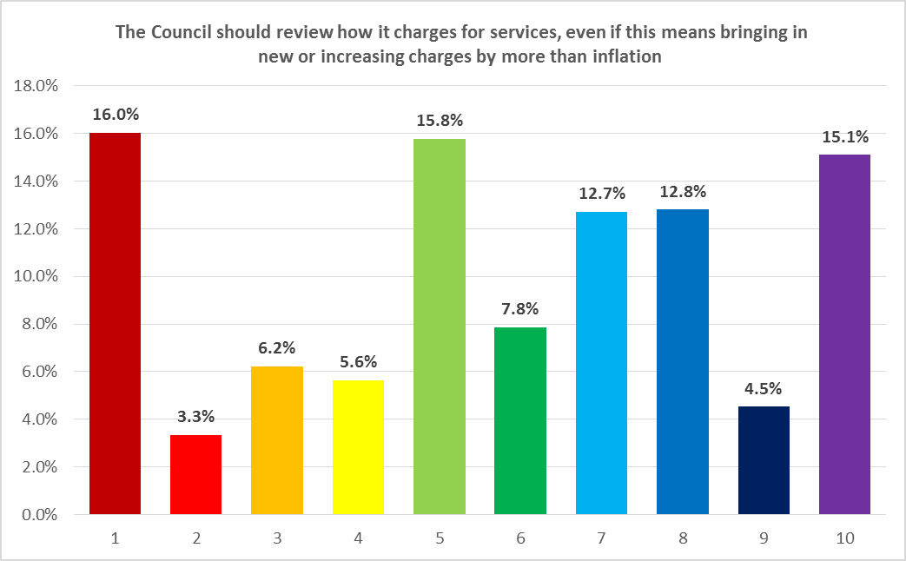
Q8: The Council should review how it charges for services, even if this means bringing in new or increasing charges by more than inflation | Percentage
1 | 16.0%
2 | 3.3%
3 | 6.2%
4 | 5.6%
5 | 15.8%
6 | 7.8%
7 | 12.7%
8 | 12.8%
9 | 4.5%
10 | 15.1%
N = 1172

Question 9
The council can also save money by reducing or even stopping some of the services it currently provides. Where 10 is completely agree and 1 is totally disagree tell us how much you agree with the following statements.
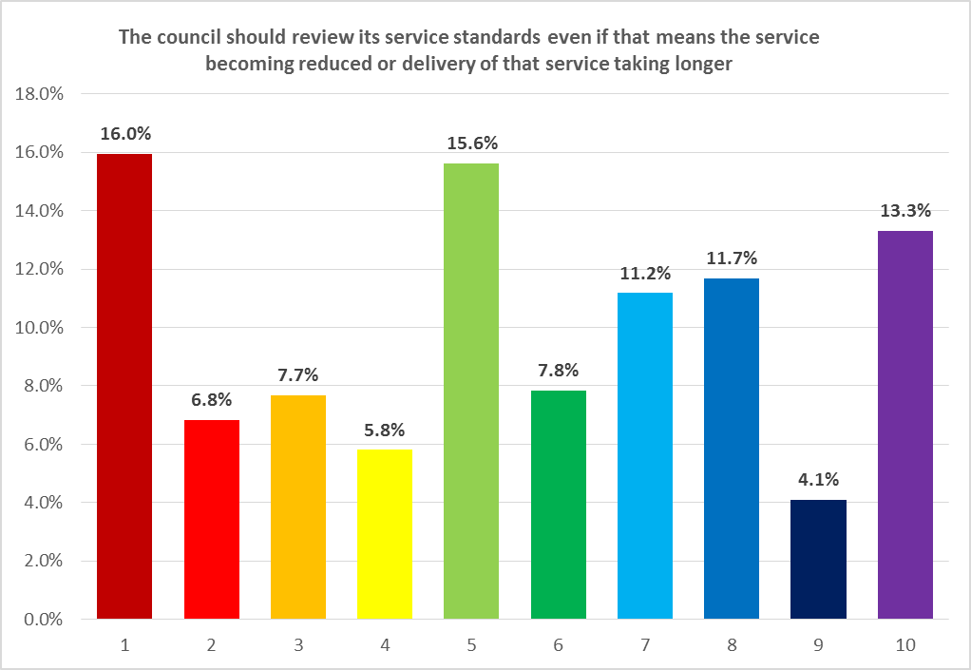
Q9: The council should review its service standards even if that means the service becoming reduced or delivery of that service taking longer | Percentage
1 | 16.0%
2 | 6.8%
3 | 7.7%
4 | 5.8%
5 | 15.6%
6 | 7.8%
7 | 11.2%
8 | 11.7%
9 | 4.1%
10 | 13.3%
N = 1172

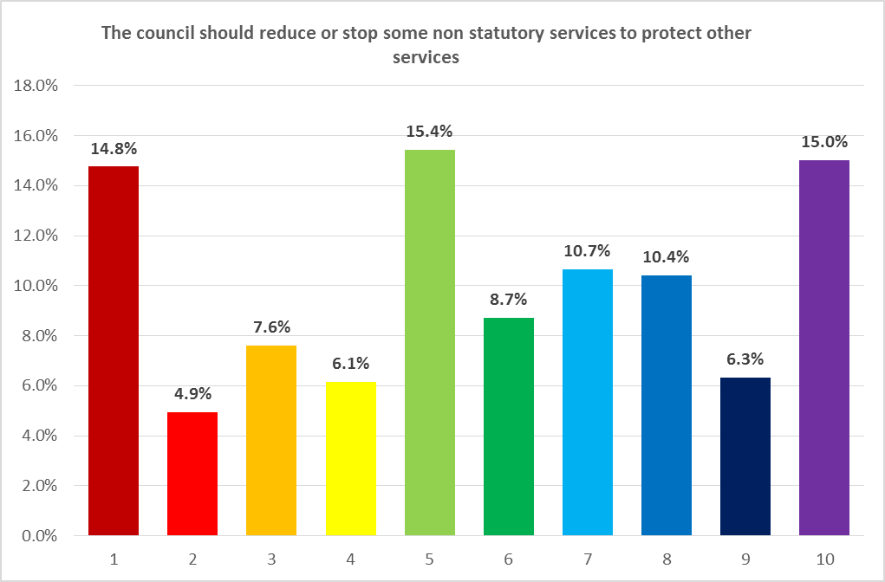
Q9: The council should reduce or stop some non-statutory services to protect other services | Percentage
1 | 14.8%
2 | 4.9%
3 | 7.6%
4 | 6.1%
5 | 15.4%
6 | 8.7%
7 | 10.7%
8 | 10.4%
9 | 6.3%
10 | 15.0%
N = 1172

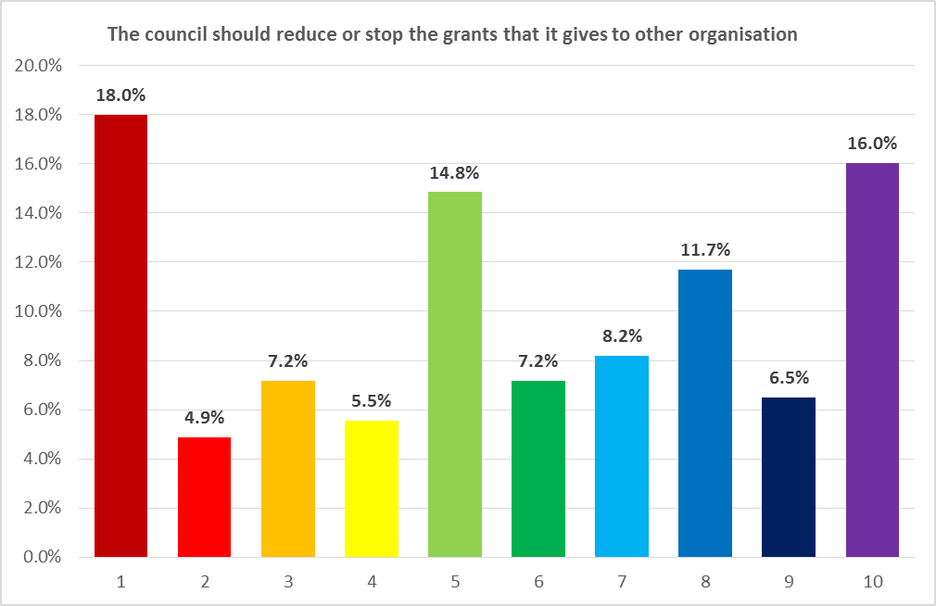
Q9: The council should reduce or stop the grants that it gives to other organisations | Percentage
1 | 18.0%
2 | 4.9%
3 | 7.2%
4 | 5.5%
5 | 14.8%
6 | 7.2%
7 | 8.2%
8 | 11.7%
9 | 6.5%
10 | 16.0%
N = 1172

Question 10
Another way of saving money is to think about where and how council services are delivered. Where 10 is completely agree and 1 is totally disagree tell us how much you agree with the following statements.

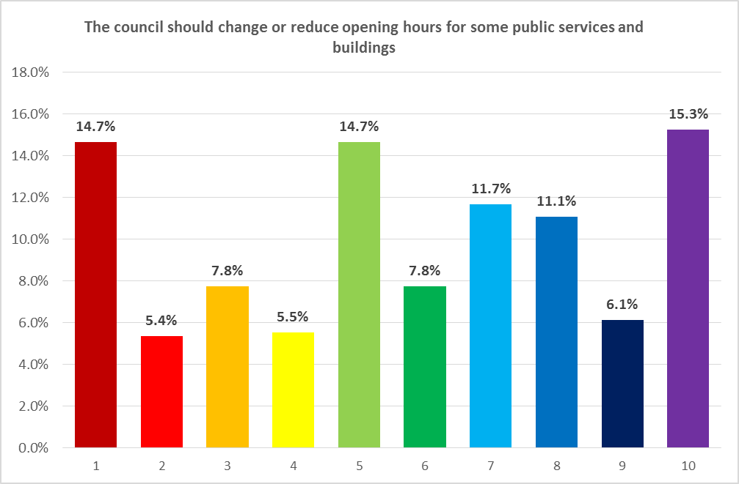
Q10: The council should change or reduce opening hours for some public services and buildings | Percentage
1 | 14.7%
2 | 5.4%
3 | 7.8%
4 | 5.5%
5 | 14.7%
6 | 7.8%
7 | 11.7%
8 | 11.1%
9 | 6.1%
10 | 15.3%
N = 1172

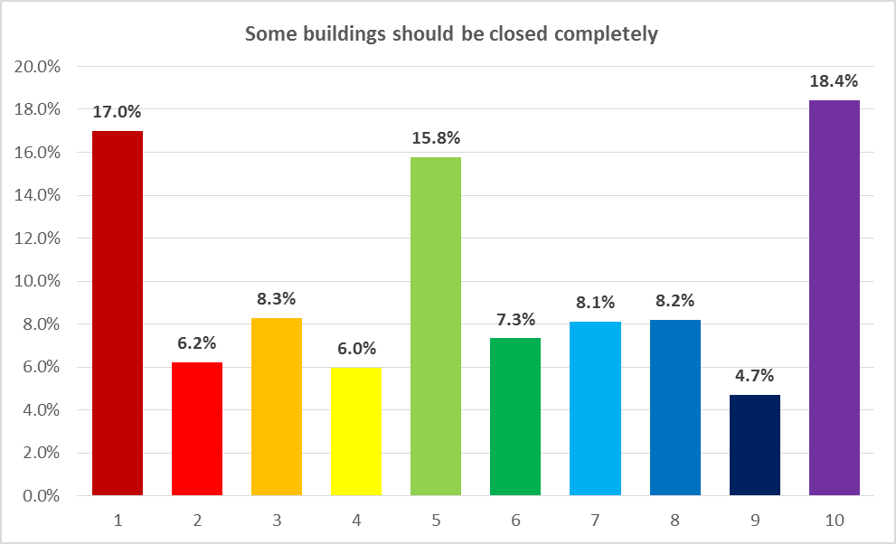
Q10: Some buildings should be closed completely | Percentage
1 | 17.0%
2 | 6.2%
3 | 8.3%
4 | 6.0%
5 | 15.8%
6 | 7.3%
7 | 8.1%
8 | 8.2%
9 | 4.7%
10 | 18.4%
N = 1172

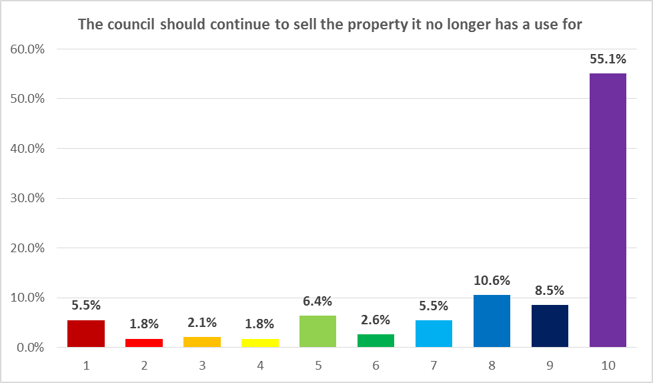

Q10: The council should continue to sell the property it no longer has a use for | Percentage
1 | 5.5%
2 | 1.8%
3 | 2.1%
4 | 1.8%
5 | 6.4%
6 | 2.6%
7 | 5.5%
8 | 10.6%
9 | 8.5%
10 | 55.1%
N = 1172

Notes;
The responses to the above were collated via an online survey made available on the Dundee City Council website between 7th November and 31st December 2018.
As with any exercise of this type, results are indicative and will be influenced by the demographic of those who choose to make a submission, and cannot be considered representative of all DCC citizens. 10% of responses were made by persons living out with the City council boundary.

