Additional Support Needs, Educational Psychology & Inclusion Services:
Guidance for Schools and Early Years Communities

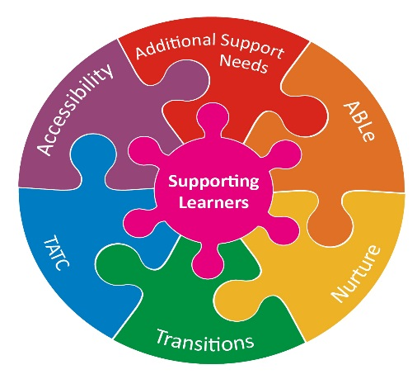

Assistance and intervention to support inclusion in Dundee
- Introduction The Children and Families Service provides support within a staged intervention framework to nurseries, schools, families and partner agencies for children and young people with additional support and wellbeing needs. We have a range of city-wide teams which work together closely to: help implement council policy and relevant guidance; support school improvement planning; develop and deliver staff development and training in relation to meeting the needs of children with ASN; provide advice in relation to the support and education of children with ASN. In some cases this may include direct targeted support to children and young people. While each of the services have specialisms which can be targeted at specific needs, and arise from legislation, local and national priorities, they all aim to achieve the overarching outcome in the Dundee City and Tayside Plans:
Our children and young people who experience particular inequalities and disadvantage will achieve health, wellbeing and educational outcomes comparable with all other children and young people.

- Service Provision
The roles and responsibilities of each service are outlined below with details of how to access them.
2.1 Education Manager for ASN, Educational Psychology and Inclusion:
Has lead responsibility for continuous improvement in support services and specialist establishments, including the management of the Educational Psychology Service and all aspects of complex and additional support needs within the Children and Families Service. She works closely with managers within the Children & Families Service, NHS Tayside; Health & Social Care Partnership (HSCP); and the Voluntary Sector to plan strategically to improve integrated service delivery, e.g. Autism Strategy; partnership agreements with Allied Health Professionals; and strategic commissioning for those in transition to adult life. She manages the provision for children and young people with a range of complex needs, including the Accessibility & Inclusion Service; Kingspark School; Off-Site Education Service and Rockwell Learning Centre; and Dudhope Young People’s Unit.
Email jennifer.king@dundeecity.gov.uk
2.2 Education Support Officer (ASN): works collaboratively with schools, other agencies and services to provide information, advice and signposting. She is involved in planning, developing and delivering training- and in developing and writing policies and guidance in relation to ASN. She can provide mediation related to school placements, which have not been able to be resolved despite significant input from school staff. She works closely with Allied Health Professionals and the Support for Learning Training Officer (2.6) in planning for and sourcing specialist equipment and resources, and identifying accessibility requirements across nursery and school communities. She coordinates the SLMG process throughout the year and the allocation of Learning & Care Assistants to schools.
Email: jkerr836@dundeeschools.scot

2.3 Dundee Educational Psychology Service (DEPS)
Educational Psychologists are trained in child development including additional support needs, the psychology of how we learn, the psychology of change, the science of implementation, factors giving rise to additional support needs, attachment, research skills, assessment, mental health and wellbeing, resilience, and wide range of other psychological skills. All schools, early years settings, specialist provisions and residential children’s houses in Dundee have a link Educational Psychologist, as do all looked after children from Dundee who are placed in other local authority areas for their care and education.
The Educational Psychology Service have a statutory duty to provide advice and support to the local authority including schools and nurseries on how best to meet the education and wellbeing needs of children and young people with ASN, including those that are looked after.
In order to deliver on this statutory function, DEPS offer the five core functions of an educational psychologist, namely: Consultation, Assessment, Intervention, Research/Evaluation, and Staff Development/training. Any of these 5 key roles can be applied in relation to a question about an individual case, to help address a wider systemic issue within a school/nursery/children’s house, or as part of an EPs contribution to various relevant local authority strategic groups where we have representatives. The priority focus of our work is the inclusion of children with additional support needs, raising attainment, and addressing children and young people’s wellbeing needs including mental health. We also have responsibility for educational planning for care experienced children and young people.
Contact the service:
School/Nursery: an annual discussion at the start of each academic session is the basis for joint planning between the link EP and the organisation, and plans are regularly reviewed if need be at a routine visit. Schools/nurseries/other partners can also contact their EP directly at any time by calling the office or emailing them.
Parents’/Carers: In the first instance, parents/carers should discuss any concerns about their child with the relevant school or early years staff. However, parents are also welcome to contact the educational psychology service directly for advice on 432980 or email dundee.eps@dundeecity.gov.uk
Other agencies: contact the office directly 432980, request access through the nursery or school, or email dundee.eps@dundeecity.gov.uk
Further information at: http://www.dundeecity.gov.uk/deps

2.4 Accessibility and Inclusion Service (AIS)
The Accessibility and Inclusion Service has been established in response to the diverse range of additional support needs identified in Dundee. It has been formed from remodelling the Multisensory Support Service; the Bilingual Pupils’ Support Service and the Outreach Team (0-18). The AIS provides support within a staged intervention framework to nurseries, schools, families and partner agencies for children and young people with additional support needs on a locality basis. The service works closely with other central, city-wide teams to:
- help implement council policy and relevant guidance;
- support school improvement planning;
- develop and deliver staff development and training in relation to meeting the needs of children with ASN;
- and provide advice in relation to the support and education of children with ASN, which in some cases may include direct targeted support to children and young people.
In doing so, the Accessibility and Inclusion Service aims to achieve the overarching outcome in the Dundee City and Tayside Plans:
Children and young people who experience particular inequalities and disadvantage will achieve health, wellbeing and educational outcomes comparable with all other children and young people.

The AIS is led by two Depute Head Teachers, supported by a team of Principal Teachers, all of whom have specialisms which enable the service to respond to a diverse range of needs as follows:
- Social Communication Needs including Autism:
In-depth advice, consultation, training and practical support to families, nurseries and schools regarding children and young people with social communication needs including Autism. This involves close partnership working with other agencies including allied health professionals.

- Visual Impairment & Deafness:
Working in partnership with parents and colleagues from other agencies, the service offers support to families and to staff in nurseries and schools, including assessment of vision/hearing, adaptation of resources, communication support, direct teaching, training in mobility and independent living skills, use of specialist equipment, advice on adapting the learning environment and/or curriculum.
The service offers tailored awareness-raising packages for staff (individuals, small groups or whole-school) and pupils at all stages. Training and support in the use of specialist equipment is also provided.

In addition, the service provides British Sign Language communication support for deaf parents of hearing children, for school meetings, parents’ evenings, etc.
Referrals come mainly from NHS colleagues. Should you wish to discuss anything regarding children/young people with sensory loss, or to request communication support, please call Barbara Burns, Educational Audiologist/Depute Head teacher on 01382 438055 or email barbara.burns@dundeecity.gov.uk

- Bilingual pupils: providing support for children and young people for whom English is an additional language. This may include direct teaching, adaptation of mainstream materials, bilingual resources, translation & interpreting services, SQA ESOL examinations, community language exams in a range of languages, bilingual speech and language therapy and advice, consultation and training.

- Home/Hospital Teaching: for those pupils who are unable to attend school due to prolonged ill health. This is a service which is provided for pupils who are absent for a minimum of three weeks or more for medical reasons, e.g. recovery from surgery, immobility after accidents.

- Elective Home Education (home schooling): Assessment in relation to whether a request for home education should be agreed or not, is carried out by teachers in the service, along with The Principal Officer (Strategy & Performance Team). Assessment reports are prepared and subsequent recommendations are made to the Executive Director, Children & Families Service for a decision.

- Educational support for Looked After, Care Experienced children and young people: in consultation with social work colleagues and school staff, short-term, targeted educational support is provided for children and young people whose education and care placement are at risk.

- Traveller* Education: Support is provided, where possible, in local schools or at the Travellers’ site. We also provide parents with practical advice and support and encourage parents to collaborate fully in the educational process.
*please note: the term ‘Traveller’ is used to refer collectively to those with a mobile lifestyle and/or culture, including, but not exclusively, European Roma, Scottish Gypsy/Travellers and Showpeople or Showmen.

- School refusal (due to significant emotional/mental health needs): designated teachers from the service provide educational support to the AIM Programme for young people of secondary age who are unable to attend school due to significant anxiety and social communication needs.

- Gaelic Medium Primary Education (GMPE): GMPE is an option within Scottish schools that gives children and young people the opportunity to become proficient in both Gaelic and English. Parents of a child who is under school age and has not commenced attendance at a Primary school, have the right to request an assessment of the need for GMPE in Dundee. Initial Assessments are undertaken by AIS. Parents receive a written response within six weeks. If the Initial Assessment finds potential demand, AIS carries out a Full Assessment. Within ten weeks, the Full Assessment report will be completed. The report will set out Dundee City Council’s decision; its reasons for reaching the decision and when it intends to commence GMPE, if this decision has been reached.

Contact details:
The Accessibility & Inclusion Service is based at St Paul’s RC Academy and St Ninian’s RC Primary School.
Email: accessibilityinclusion@dundeeschools.scot
Phone: 01382 438099 Referral form Appendix 1

2.5 Kingspark Outreach – designated staff from Kingspark School provide advice, consultation and moderation on differentiating the curriculum and approaches for children and young people at an early developmental stage and with Complex ASN.
Access: email to Paul Dow at Kingspark. pdow902@dundeeschools.scot
2.6 ASN Training Officer
The ASN training officer provides advice, consultation and moderation on CALM Interventions, De-escalation and Responsive Care Planning Outreach. She also provides training in relation to CALM, Moving and Handling, Administration of Medication, De-escalation and Nurturing Approaches. She can also advise on accessibility assessments, specialist equipment and reasonable adjustments in consultation with education staff, Allied Health Professionals and other agencies.
Referral Process: see referral form in Appendix 2
susan.mclaren@dundeecity.gov.uk

  - Longhaugh Support Group (LSG):
LSG provides outreach advice and support to primary schools in relation to children who have complex social emotional and behavioural needs, including trauma and attachment.
Access: LSG Application form Appendix 3
Mkearns17@dundeeschools.scot

2.8 AIM (Anxiety in Motion): The purpose of AIM is to provide an education and wellbeing programme for young people of secondary age, who are unable to attend school due to experiencing a variety of mental health difficulties. The AIM programme supports them to attend, learn, share and develop in a more meaningful and purposeful way in a place other than school (while remaining on the school roll). AIM has been developed in partnership with the young people and in an environment where the young person’s emotional needs for connection, belonging, to be valued and to feel success are met in a positive way.
Referral process: school referral from (Appendix 4)

- Assessment and Planning for pupils with ASN:
The Assessment and Planning for Pupils with Additional Support Needs Guidance should be followed, which outlines the processes used in nursery and school to plan and support children and young people with ASN in our schools.
Where there is an ongoing issue for a child or young person, which often relates to:
- Social communication need including autism;
- Distressed behaviour;
- Attachment; or
- Trauma
there may be a need for targeted support or intervention. In order to provide the appropriate support for the child or young person and relevant staff, the City Wide ASN and Inclusion Services will meet to consider the children and young people who have been referred to them. This will prioritise need, reduce waiting times and ensure that interventions are planned and referrals made to the correct services. This will take place on a monthly basis. The flowchart below outlines the process.

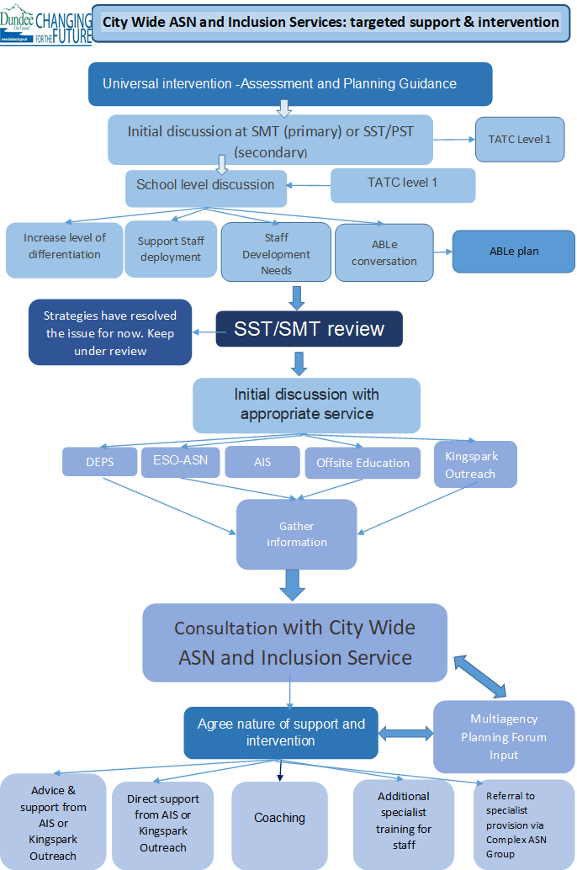

Summary of services
 | ESO- ASN | DEPS | Accessibly and Inclusion Service | Kingspark Outreach | ASNTraining Officer | LSG Outreach
Universal | Training:  Policy and Guidance | Training:  Research and evaluation:  Policy and Guidance | Training: | Training: | Training: | Training:
Additional | Advice and Consultation | Advice and Consultation | Advice and Consultation | Advice and Consultation | Advice and Consultation | Advice and Consultation
Targeted | Planning and Training  Accessibility | Individual Support  Assessment and Intervention  Planning and Training | Individual Support, including direct teaching  Assessment and Intervention  Planning and Training | Individual Support  Assessment and Intervention  Planning and Training | Planning and Training  Accessibility | Individual Support  Assessment and Intervention  Planning and Training
Specialist | CALM | Trauma | AIM | CLPL programme | CALM | De-escalation

Scottish Government National Legislation and Guidance

Tayside Plan & Local Outcome Improvement Plan
Integrated Children’s Services TATC Framework: GIRFEC
TATC Framework including SLMGs & transitions
Additional Support for Learning (Scotland) Act (2004, amended 2009)

Standards in Scotland’s Schools Act (2000)

Education Scotland Act (2016)
How Good is Our School 4 (2015)

The National Improvement Framework (2016)
Equalities Act (2010)
Attainment Challenge
Local Improvement Plan
Tayside Children’s Plan
How Good Is Our School 4
3.1
Children and Young People (Scotland) Act (2014)
Nurturing Approaches in Dundee
Equality and Accessibility Strategy

Additional Support for Learning

Autism Strategy w.r.t. co-occurring needs
Action Plan
Dundee City Council Strategic Guidance

