Will the school staff know how to meet my child’s needs?
Yes, as well as sharing assessment information, school staff will work closely with other professionals to meet your child’s needs. This may include input from the link Educational Psychologist, Accessibility and Inclusion Team, and/or other specialists such as Speech and Language Therapists, and Teachers of Hearing/Visual Impairment. If they are involved, they will work closely with school staff to help assess, plan and review the support for your child.
How can I find out more about the planning and support in my child’s local community?
You will be invited to a transition meeting in October when you will have the chance to discuss the support needs of your child. This will give you the opportunity to find out about the kind of support provided in your local community for your child.
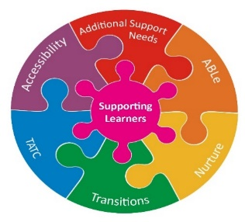

Frequently Asked Questions for parents of children with additional support needs
Will I be involved in the planning and reviewing of my child’s needs?
Yes, families are always involved in the planning and reviewing of their child’s needs, particularly leading up to transition to Primary 1 or Secondary School. This will involve you meeting with the Team Around your Child and forming a Child’s Plan, and to ensure that you know how information about your child will be shared in the transition process.
How will my child be supported in school?
The information which has already been gathered from you and other professionals who know your child will be shared with school staff. This information will describe your child’s strengths and developmental needs. These can be identified using the wellbeing indicators which are known as SHANARRI. This involves reviewing your child’s development and needs under the headings of Safe, Healthy, Active, Nurtured, Achieving, Respected, Responsible and Included.
These can be identified using an ABLe Plan or Single Child Plan which details your child's strengths and progress, the impact that any barriers have on their learning and the strategies that are in place to support them.
The co-ordinated support which your child may receive will be based upon the information in their transition planning and may include:
- How the learning environment can be adapted to meet your child’s needs
- The level/type of adult support and interaction which your child needs to learn
- Any routines and approaches, such as the use of visuals/symbols, which will help your child
- Any physical access adaptations that need to be made in the nursery or school

These supports are reviewed regularly (at least annually) and for many children, the support will change as they develop skills and gain independence. This means that they might spend more time in groups or whole class settings and less time with an adult supporting them for certain times in their day. If they need transport to school, this will also be reviewed to see if it is still required.
All local communities have schools which have Enhanced Support Areas. These schools provide other schools in the community with:
- access to staff with relevant experience, training and skills
- advice on the use of specialist resources
- advice on adapting the learning environment
How is the type of support for my child decided?
The Supporting Learners Management Group meets three times a year to discuss the complex needs of pupils who will be in transition and require enhanced and coordinated additional support in school. This group includes Headteachers of local schools, along with the Educational Psychologist, Nursery Headteacher/manager, and other specialists from Health who may have been involved with your child. They will have assessment information and recommendations of what kind of support your child will need in school. The group will also take other things into account such as:
- children remaining in their local community wherever possible to attend school
- the complexity of children's needs, where those with the most complex, lifelong needs are considered for specialised provision
- all local community schools having a range of knowledge and skills to meet a wide diversity of learning needs

