To access this document please use the following links. This will ensure you are working from the most up-to-date version of the framework.
Internal Link External Link 'DCC Literacy Difficulties and Dyslexia Framework Feb 2021.docx' ( this file date refers to the original update but it does lead you to the most recent up date)

Dundee City Council
Children and Families Service
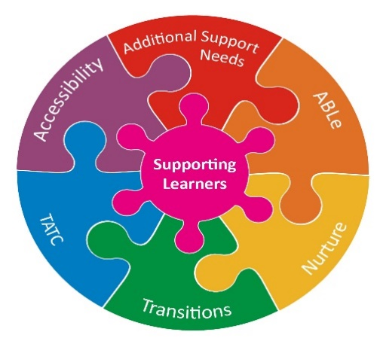

Guidelines for the identification and support of literacy difficulties including dyslexia

January 2022

