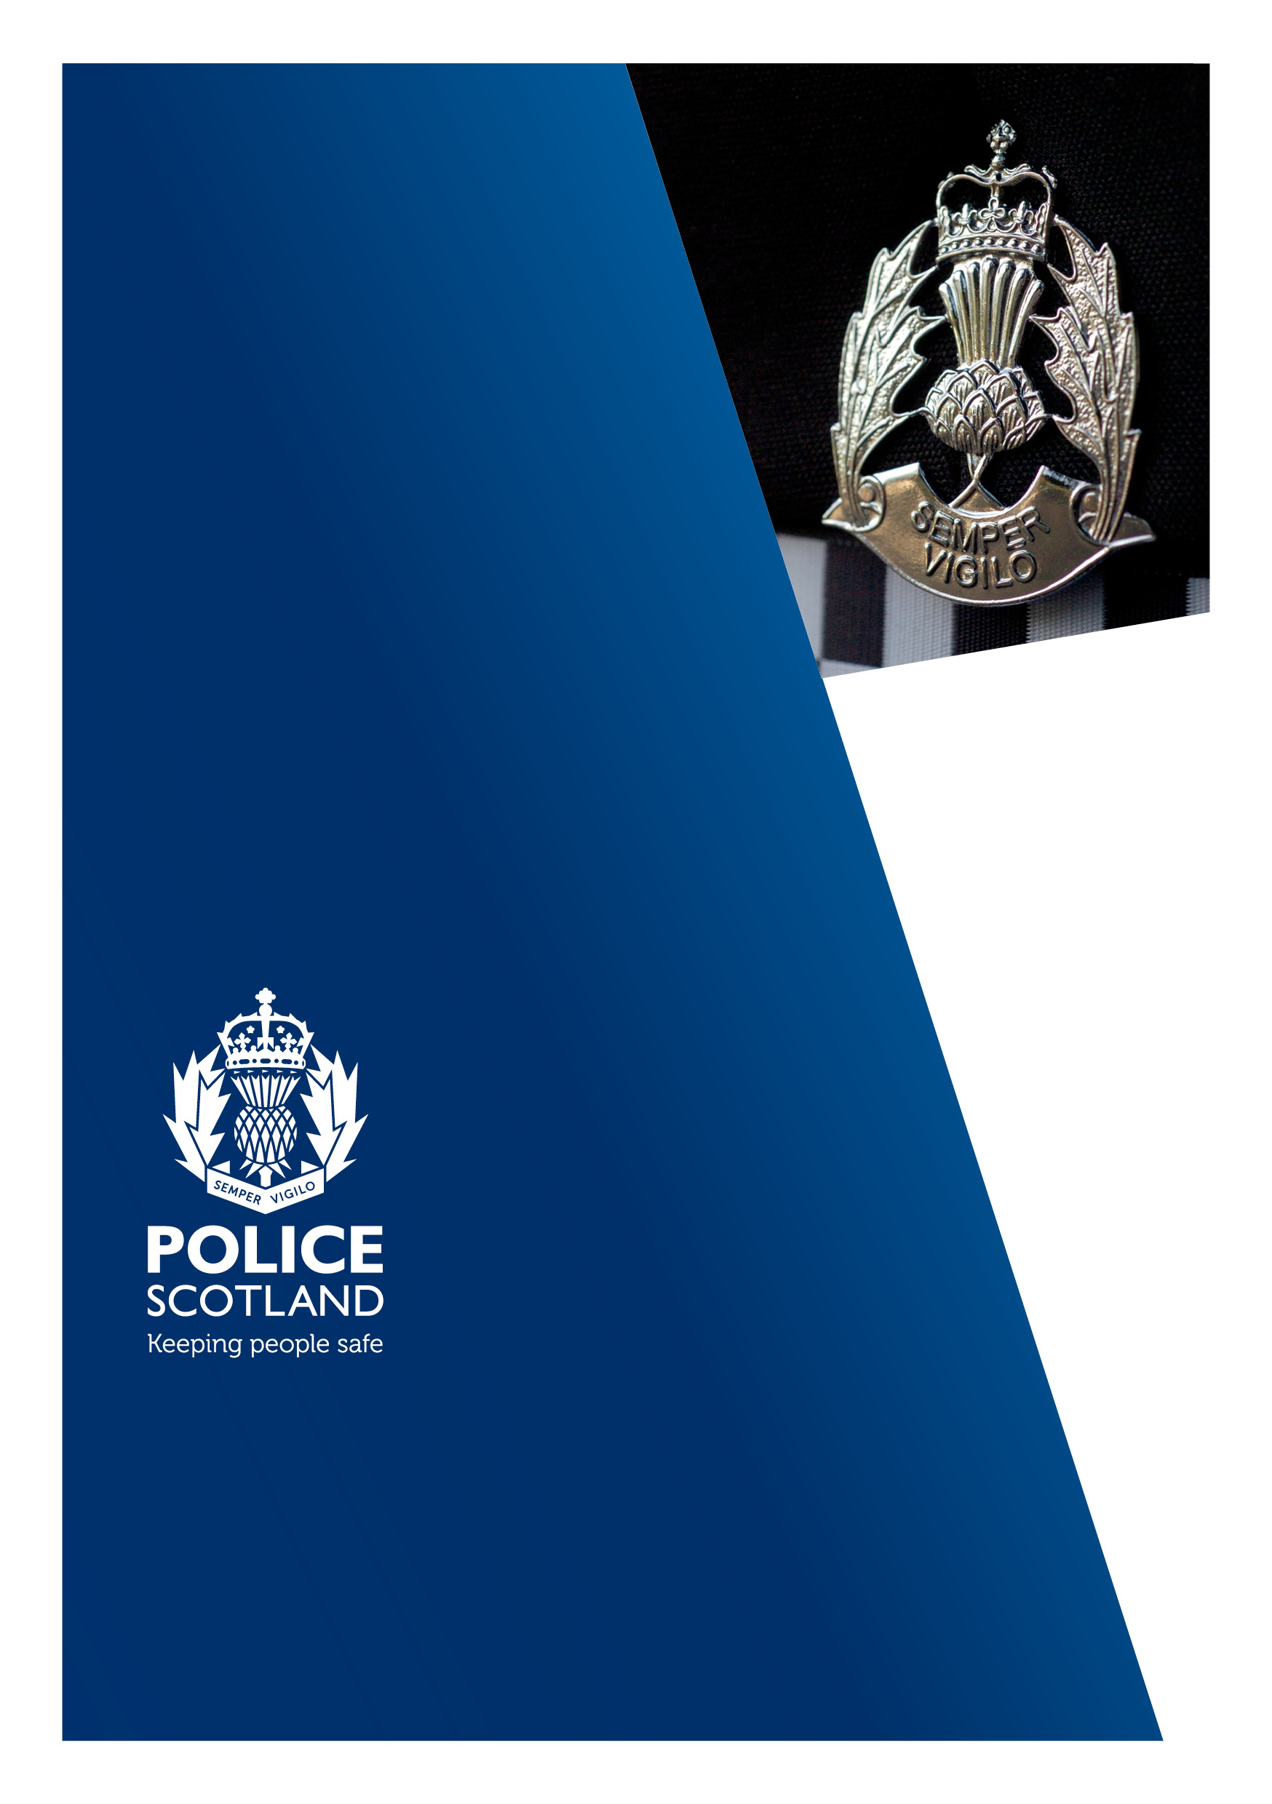
DUNDEE
Licensing Report
2021-2022

Foreword
It gives me great pleasure to provide the Annual Licensing Report for 2021/22, in accordance with Section 12(A) Licensing (Scotland) Act 2005. Throughout this year Local Authorities and Police Scotland worked hard to support licensed premises in their road to recovery as Covid-19 restrictions were being lifted.

Collaboration is vital to ensure these businesses can flourish, providing much needed employment for our communities as well as a safe environments for people to socialise. Police Scotland will continue to work closely with Local Authorities, as well as other stakeholders, to ensure there is a fair and consistent approach across all 32 Local Authorities throughout Scotland to aid this recovery. Preventing alcohol fuelled violence, disorder and antisocial behaviour remains a priority for Police Scotland and I believe that working together we can reduce this through early intervention and enforcement.

I would like to take this opportunity to thank our local partnerships and the good work they carry out. With their support Police Scotland and partners can continue to drive improvements in licensing. I will continue to ensure that all officers and staff recognise the importance of working together with key partners, including the Licensing Trade, in an effort to improve licensing standards nationally.

Mr Iain Livingstone QPM
Chief Constable
Police Service of Scotland

Police Scotland Licensing Overview –
The Violence Prevention and Licensing Co-ordination Unit (VPLCU) sits within Safer Communities based at Dalmarnock Police Station, Glasgow.
The VPLCU upholds the two tier structure for licensing which supports both national and local priorities through service delivery. They have overall responsibility for determining and delivering national licensing strategy and policy, by providing advice, guidance and support to divisional licensing teams as well as undertaking other specialist functions.
The Violence Prevention and Licensing Co-ordination Unit is a specialist department which consists of a small team of officers, based in Glasgow. The officers within the unit work with divisional licensing teams and partner agencies to help shape policy and strategy around the police licensing function. They provide practical and tactical advice to police licensing practitioners, operational officers, supervisors and policing commanders.
The VPLCU seek to ensure that legislation governing the sale and supply of alcohol is applied consistently across the country and all opportunities are taken to stop the illegal or irresponsible sale, supply or consumption of alcohol with the intention of preventing and reducing crime and disorder.
During 2021/2022, from a licensing perspective, our particular focus was on the following;
- Scrutiny of the serious incidents of violence, disorder and antisocial behaviour linked to licensed premises.

- Working closely with Licenced Premises and Scottish Government to navigate the challenges of the COVID-19 pandemic through the 4Es approach by engaging, explaining, educating and enforcing.

- Governance and ongoing development of the National ICT Licensing System, known as “Inn Keeper”, to increase the efficiency and effectiveness of liquor and civic licensing administration and management. Police Scotland are currently working on upgrade to the National ICT system to ensure compliance with GDPR legislation.

Each of the 13 Local Policing Divisions have a licensing team responsible for the day to day management of licensing administration, complying with statutory requirements as well as addressing any issues that may arise within licensed premises in their local area.

LICENSING BOARD AREA
The Licensing Board area is policed by Tayside Division.
Chief Superintendent Phil Davison is the Divisional Police Commander who has the responsibility for all day-to-day policing functions.
Chief Inspector Ross Fitzgerald is the Local Area Policing Commander for Dundee.
Senior Officers
Inspector Jamie Allen is the Head of Licensing Department and he is responsible for the overall supervision of the department.
Sergeant James Gordon is Licensing Sergeant and he is responsible for the day to day management of the department and staff.

Local Policing Priorities
Following our public consultation process, the policing priorities for Dundee, as set out in our Local Policing Plan 2020-2023 are as follows;
- Violence, Disorder and Antisocial Behaviour
- Acquisitive Crime
- Road Safety and Road Crime
- Public Protection
- Counter Terrorism and Domestic Extremism
- Serious Organised Crime
These are underpinned by our values of Integrity, Fairness and Respect.

Description of Board Area
Dundee sits on the north bank of the Firth of Tay on the eastern, North Sea Coast of Scotland. The City occupies a roughly rectangular shape of 8.3 miles long and 2.5 miles wide, aligned in an east to west direction and occupies an area of around 60 square kilometres and is populated by around 148,820 people.
Dundee is known as the “City of Discovery”, named after Captain Scott’s famous Antarctic exploration vessel, the RRS Discovery, which is berthed at Dundee Waterfront adjacent to the V&A Museum.
Dundee is a city with plenty of culture, a diverse range of bars and restaurants, an eclectic choice of independent shopping, art and design galleries and buzzing music and events scene.
Home to both the University of Dundee and Abertay University plus a number of great schools, the city has an exciting and varied nightlife and peaceful seaside suburbs on the doorstep.
As of March 2022, Dundee has 450 licensed premises. Of this 189 are on and off sale, 127 on sales and 134 off sales premises.

OPERATION OF THE LICENSING (SCOTLAND) ACT 2005
The Tayside Divisional Licensing Team are based within Divisional Police Headquarters, West Bell Street, Dundee. The team is led by Inspector Jamie Allen, and is supported by Sergeant James Gordon, five Police Constables and two members of Police Staff.
The team are responsible for processing all applications, on behalf of the Chief Constable, as a statutory consultee, sent from Dundee Licensing Board as per the Licensing (Scotland) Act 2005. All applications have to be thoroughly examined to ensure compliance and conformity to the five Licensing Objectives of said act.
In the reporting period 2021/2022 the team processed the following applications in comparison to previous year;
 | 2020/2021 | 2021/2022
Occasional Licenses | 696 | 1900
Personal Licenses | 54 | 84
Premises Licenses | 11 | 22
Variation to Licence Request | 102 | 157

Where any query arises from any such application, a member of the team will seek to discuss the application with either the applicant or the applicants’ agent to ensure that Police responses to the Board by means of representation or objection are considered, reasonable and proportionate.
We regularly work in tandem with officials in relation to events taking place within the city, to ensure all licensing arrangements are acceptable to all parties. We scrutinise alcohol management plans and deploy to the events to ensure all policies and procedures are followed.
The Coronavirus pandemic has had a significant impact on the licensed trade. Since March 2020, licensed premises have been subject to strict restrictions and the ever-changing guidance and legislation published by the Scottish Government has resulted in licence holders and their staff being required to carry out detailed and comprehensive COVID-19 risk assessments, whilst operating their businesses under strict regulations to ensure the safety of patrons and staff. This has undoubtedly been a very challenging time for all concerned.
Police Scotland has worked in close partnership with the Environmental Health and Licensing Standards Officers to actively support and provide advice and information to licence holders. This has been important to ensure a collective and joint working approach so that agencies, including the police, are seen to be working with licence holders and not against them.
Enforcement has always been a last resort, with the focus being on engaging with individuals, explaining the regulations and legislation, and support premises in order to gain compliance.
The vast majority of licence holders have fully complied with all the regulations. During the periods where licensed premises were permitted to trade under strict regulations, which included curfews, track and trace, table service etc.
The levels of compliance have been testament to the dedication and commitment of licensees and partner agencies. There has been some intervention work carried out by the police in relation to some breaches of the COVID-19 regulations by licensed premises, however these issues were rectified with a partner based problem solving approach, and by investing time and support to address matters and ensure understanding and compliance.
Community based Police Officers are encouraged to routinely visit licensed premises within their locality areas. Dundee city centre benefits from a dedicated Weekend Policing Plan to support the night time economy.
Within the reporting period, there were 647 recorded inspections to licensed premises.
The Misuse of alcohol is often cited as a contributory factor in relation to crimes of violence, domestic abuse, disorder and antisocial behaviour. A key task for the Divisional Licensing Team is on a day to day bases to review all incidents that have occurred, either within or in the vicinity of licensed premises throughout the board area.
Any Police Officer who attends an incident at or within the vicinity of a licensed premises is expected to submit a concise record of the incident, via Police Scotland’s Inn Keeper system. This is particularly vital when the incident involves violence, disorder anti-social behaviour, drunkenness, drug misuse, underage drinking, breaches of the licensing legislation or any other matter that might impact on public safety.
All incidents reported on Inn Keeper are reviewed and assessed by Divisional Licensing Team with officers carrying out further enquiries with the attending Police Officers, the Premises Licence Holder, Designated Premises Manager and any staff involved in the incident.
Whilst the vast majority of licensed premises do operate in accordance with the legislation stipulated within the Licensing (Scotland) Act 2005, thus ensuring the provision of alcohol within a safe and regulated manner, it is imperative that any irresponsible and illegal sale of alcohol is tackled robustly by the Police.
The information obtained following the review may show a causal link between the operation of the premises and the incident. An incremental intervention process allows for issues to be addressed quickly and effectively at an early stage. This includes a low level interaction between the divisional licensing officers and the premises licence holder and or the management of the premises. The level of engagement from within the Dundee licensing trade is very good and in vast majority of cases, this approach reduces recurrence or escalation.
Licensed premises may become ‘monitored’ with closer attention being paid to any incidents occurring in or within the vicinity of the premises. This is often undertaken in conjunction with tasked, supportive visits to the licensed premises by uniformed Police Officers.
Where necessary and where the monitored process has been ineffective or assessed as not proportionate, the process allows for more formal option such an ‘Intervention Plan’ to support and ensure the licensed premises holder and personal licence holder uphold the licensing objectives.
Within the reporting period there were two licensed premises within the Board area that had agreed action plans with the Divisional Licensing team. The length of time was six months, with both plans contributing to a successful reduction of adverse incidents and improved the overall public safety within the community.
Within the reporting period, there were 505 recorded incidents to licensed premises within the Board area.
Divisional Licensing officers work in tandem with the Dundee Licensing Standards Officers. We share information and intelligence on a regular basis, often adopting joint approaches to tackling incidents within licensed premises, including noise complaints or anti-social behaviour through proportionate and effective enforcement of the licensing legislation and working practices.
Below is the number of licensing offences recorded between 1st April 2021 and 31st March 2022;
Offence | 2021 / 2022
Section 1 – Unlicensed sale of alcohol | 0
Section 63 – Sale or supply out-with licensed hours | 1
Section 111 – Drunk person entering or in premises on which alcohol is sold | 1
Section 111 (2) – Drunk and Incapable on relevant premises | 0
Section 112 – Obtaining alcohol by or for a drunk person | 0
Section 113 – Sale of alcohol to a drunk person | 0
Section 114 – Premises manager, staff not to be drunk | 1
Section 115 – Drunk / Disorderly conduct on premises | 0
Section 116 – Refusal to leave licensed premises | 9
Section 138 – Obstructing Constable entering licensed premises | 0

Within the reporting period, the Divisional Licensing team submitted four applications to the Board for a review of a personal licenses. One of the licence holders subsequently surrendered their personal licence, whilst the other three licence holders had their personal licenses revoked following the review hearings.
The Divisional Licensing team also submitted an application to the Board for a review of a premises licence. The licence holder subsequently surrendered the premises licence.

PREVENTING THE SALE OR SUPPLY OF ALCOHOL TO CHILDREN OR YOUNG PEOPLE
Protecting children and young persons from harm is one of the five licensing objectives. Sections 102 – 109 of the Licensing (Scotland) Act 2005 are offences specifically related to children and young persons.
In terms of section 102 – the sale of alcohol to a child or young person, the premises licence holder has vicarious liability (subject to a due diligence defence) in relation to these offences.
The Act defines a child as a person under the age of 16 years, and a young person as a person aged 16 or 17 years old.
Drinking alcohol under the age of 18 can affect the normal development of vital organs and functions, and is associated with increased health risks and increased criminal activities in under 18’s leaving them vulnerable and susceptible to exploitation.
Keeping People Safe is a high priority for Police Scotland, and we remain committed to focusing on engagement with children and young persons.
Police have a vital role in ensuring compliance with the licensing objective of protecting children and young persons from harm, and in preventing the sale and supply of alcohol to children and young persons. Partnership working is vital, specifically the sharing of information between different agencies, with the focus being on prevention, intervention and education the Police within Tayside continue to work tirelessly to address such issues.
Generally within the Tayside area proxy sales has not been a prevalent issue over the last year or so and have recorded no incidents of Proxy sales within the Dundee Board area.
In instances where children or young persons are found to be under the influence of alcohol, or have alcohol in their possession, relevant details are recorded on the Vulnerable Persons Database to ensure they are dealt with by the appropriate service and agencies. This option is preferable to criminalising all actions, although criminal proceedings may still be taken dependent on the seriousness of any crimes or offences
The age verification ‘Challenge 25’ scheme is actively encouraged in all licensed premises (both on and off sales) at the point of sale, and is an effective tool to prevent the sale of alcohol to children or young persons.
There were no Test Purchasing Operations carried out during the period of this report. This was partly due to a review and reform of the procedures and processes adopted, which specify that all such operations must be intelligence led with stringent safeguards in place.
Consideration will be given to carrying out Test Purchase Operations in the future, where there is credible intelligence identifying such issues.

TACKLING SERIOUS AND ORGANISED CRIME
Serious and Organised Crime (SOCG) remains both a national and local priority for the Tayside Division. Serious and Organised Crime encompasses a vast array of criminality, and its members may use licensing to seemingly legitimise their incomes, providing a plausible source of revenue whist acting as a cover for illegal activities, such as drug dealing, human trafficking and money laundering.
Police Scotland works closely with our partners to prevent harm caused to individuals, communities and businesses by Serious and Organised Crime.
Serious and Organised Crime exploits honest, law-abiding citizens, including the most vulnerable members of our communities, with the impact having devastating effects upon communities. The Dundee area is in no way immune from this type of crime.
It should be noted that SOCGs do not restrict themselves to geographical boundaries such as those surrounding local authority areas, and Serious and Organised Crime Groups will unfortunately impact on all communities.
Activity
The Divisional Licensing Team works in conjunction with other departments within the Police, such as the Divisional Intelligence Unit (DIU), the Criminal Investigations Department (CID), the Community Investigation Unit (CIU) and the Preventions, Interventions and Partnerships Team (PIP), to prevent such illegitimate business entering the licensing trade, and to work collaboratively to disrupt such activity.
As previously described, every application from the Dundee Board is scrutinised to ensure no links to Serious and Organised Crime Groups. Several police systems, including the Scottish Intelligence Database (SID) are interrogated, whilst applicants are regularly interviewed and their premises inspected during the vetting process. By doing so, the risk of Serious and Organised Crime Groups infiltrating and utilising the licence trade to furtherance their criminality is minimised.
We have continued to focus on our four objectives to;
- DIVERT – Divert people from becoming involved in serious organised crime and using its products
- DETER – Deter Serious and Organised Crime Groups by supportive private, public and third sector organisations to protect themselves and each other
- DETECT – Identify, detect and prosecute those involved in serious organised crime
- DISRUPT – Disrupt Serious Organised Crime Groups
Tayside Division continues to carry out intervention to prevent SOCGs operating without being challenged, and will continually seek opportunities to identify SOCG activity. This is through intelligence gathering and conducting days of action along with partner agencies, focussing on illegal activities that may involve liquor licensed premises
As in the past, the Divisional Licensing Team will objected and share intelligence with the Board of a person or group linked to SOCGs attempting to utilise the licensing process to obtain a licence.

PROPOSED ACTIVITY FOR THE YEAR AHEAD
Throughout the pandemic, and thereafter, local police officers and the Divisional Licensing Team have, and will continue to work towards achieving local and national priorities. By tackling alcohol related violence and disorder, and ensuring strict adherence to the licensing objectives, whilst upholding strong partner relations, together we will work towards safer and more resilient communities.
On 14th March 2022, a new dedicated City Centre Policing Team was launched. This consists of an Inspector, 3 Sergeants and 24 officers spread across 3 teams covering the period 0800 hours to 0100 hours, Sunday to Thursday, with a 0400 hours finish on Friday and Saturday night supporting the night time economy in the City Centre.
The teams mainly patrol on foot with the support of a van allowing them to respond to incidents in the City Centre, working towards local policing priorities and creating a safer environment for residents and visitors.
The management team represent Police Scotland on the City Centre Forum and have regular contact with the City Centre manager allowing for ongoing engagement with key stakeholders, including those relevant to the night time economy.
Over the last year, reports of spiking by injection circulated on social media and were picked up by the media. This resulted in an increase in reports to police forces across the UK, including Police Scotland. This has come in the midst of a national discussion about Violence Against Women and Girls, concerns around women’s safety and calls for more to be done to keep women safe.
Police Scotland has a role to play in issuing advice and information around spiking, to provide reassurance and to warn perpetrators that we are taking this criminality seriously. We work in collaboration with partner organisations on prevention. This toolkit supports these objectives.
Our messaging is focused on bystanders and perpetrators. We want people to report if they see something suspicious, to step in if they think someone may be at risk or see someone behaving suspiciously.
We want to support licensees and those who work in pubs and clubs to spot the signs of spiking and ensure their premises are a safe place for all.
The Divisional Licensing Team have all received training to enable them to deliver the Bystanders awareness sessions to stakeholders. The team will be actively engaging with Licensees to offer awareness sessions to them and their staff.
It is hoped that by working with licensees we will have a deterrent effect on potential perpetrators, if they see that premises are taking real action against spiking.
The Divisional Licensing Team along with local policing teams will undertake joint initiatives and deployments with the Security Industry Authority (SIA).
We will continue to timeously process and administrate all licensing applications in a professional and diligent manner with the focus on infiltrating and disrupting Serious and Organised Crime groups, and ensuring that Licensing Boards are advised accordingly with regards to persons who are not deemed fit and proper to hold a licence.
We will continue to work in partnership with other agencies and stakeholders, including the trade to uphold the licensing objectives, ensuring our communities are safe places for residents and visitors alike, whilst continuing to ‘Keep People Safe’.
In support of the Protecting Children and Young Persons from Harm licensing objective, the Divisional Licensing team, along with community Policing teams will promote this year’s national campaign “It’ll Cost You”. This campaign is to raise awareness on the risks and penalties associated with buying alcohol for anyone under the age of 18 years old.
To conclude we would like to thank you for your continued support during what has been a challenging year for all. We have all had to adapt to a new way of working and ever changing circumstances which has been embraced by all.
We look forward to a safe and healthy 2022/2023.

