
BROWN STREET KENNELS
Tel. 01382 432100 Fax 01382 432102

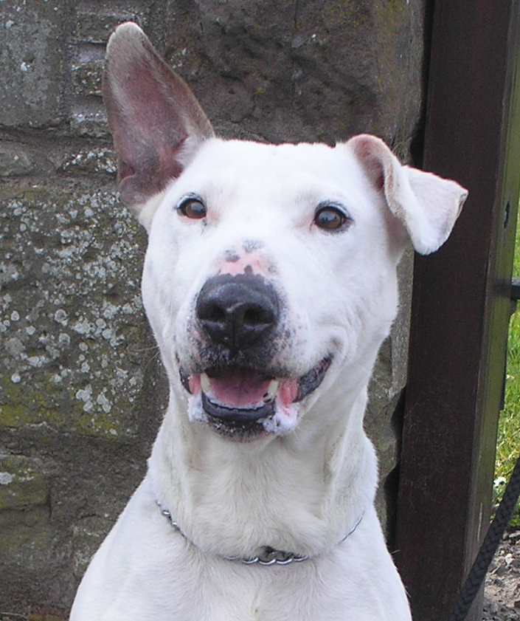

Practical Steps for Healthy Pets
Good health doesn't happen by accident and ill health has to be
prevented by positive action.

A healthy pet is a happy pet and a happy pet is a loving companion. This practical guide covers the basic things you need to know to keep your dog or cat healthy. Prevention is better than cure, so the emphasis is on explaining the simple steps you can take to safeguard your pet against ill health.

A PET'S BEST FRIEND IS THE VET
It's vital to register your pet with your local vet even if the animal is perfectly healthy. Your vet is the best person to ask about any aspect of your pet's health.
Regular check-ups are a must. Catching a problem early enough is often the key to successful treatment. And if there is an emergency you'll know immediately where to turn for help.

FLEAS – BEAT THE ITCH
Fleas irritate your pet and can even lead to more serious skin problems. Flea bites may also irritate you and your family.
What to look for: When you comb your pet, look for fleas or flea dirt on its back along the spine. Fleas are mahogany in colour and wriggle or jump. The small dark specks like coal dust are not flea eggs but droppings.
What to do: Licensed sprays, powders, flea collars, tablets, or insecticidal liquids are available from your vet. Always follow the instructions carefully before use and never use a product designed for one species on another – for example, don't use a dog product on a cat. Wash your pet's bedding frequently.
Use a powder or spray in its bed, chair, the surrounding carpet, skirting boards and don't forget your vacuum cleaner bag – and make sure you vacuum after a few hours. By treating your pet and your home, you can keep free of fleas.

WORMS
Worms can affect both dogs and cats. While there may be no obvious symptoms, your pet is better off without them and should be wormed regularly.
Roundworms – what to look for: The worms are about 5 – 15 cm (2-6 inches) long, pale white or beige in colour and coiled like a spring. They may cause vomiting and diarrhoea in young animals but adult pets may show few symptoms.
Tapeworms – what to look for: Tapeworms in dogs are often spread by fleas. Tapeworms in cats are spread by fleas, mice, shrews and voles. The commonest tapeworm produces small segments, about 7mm (1/4 of an inch) long and white or cream in colour which can be seen around your pet's bottom or in the faeces.
What to do: Treat adult animals for roundworms every 3-6 months and younger animals more frequently both before and after weaning. If your pet has tapeworms, first make sure it is clear of fleas before treatment. Licensed roundworm and tapeworm remedies are available from your vet, pharmacist, pet shop or supermarket. When dosing your pet, follow the manufacturer's instructions carefully, especially when working out the dose by weight. If in doubt always ask your vet or pharmacist.

PREVENTABLE DISEASES
Some diseases are difficult and expensive to cure and can be fatal. It is therefore important to ask your vet about vaccines to help protect your pet.
Diseases which can be prevented include:
DOGS – Distemper (hardpad), and parvovirus (causes acute sickness and diarrhoea), leptospirosis, kennel cough and infectious canine hepatitis.
CATS – Cat flu and feline leukaemia, feline infectious enteritis (or panleucopenia) and Chlamydia.
RABBITS - Myxomatosis, viral haemorrhagic disease.
Every pet should be protected against these diseases. Puppies or kittens usually start a vaccination course at 8 weeks old and should not be allowed out, or allowed to mix with other animals until your vet tells you it's safe. Your vet will give you a vaccination record card. Make sure you keep it safe and up to-date – any responsible boarding kennel or cattery will want to see it before taking your pet in.
Regular booster treatments will keep your pet protected. Your vet should let you know when your pet is due for a booster.
Bringing your pet in for its booster also gives an opportunity for your vet to give it a health check – and nip any other potential problems in the bud.

NEUTERING
If you don't want your dog or cat to have a litter it is kinder to your pet to have it neutered. In addition some behavioural problems may be avoided.
"On heat" she-cats can be noisy, whilst bitches produce a discharge and may become broody if not mated. Tom cats can smell, spray the furniture and fight. Dogs may stray, get into fights or make sudden displays of affection for cushions, chair legs or people.
Neutering does not spoil the temperament of a dog or cat.
It is a safe procedure and can be done at any age. Your pet will not realise that anything has changed.

The Five Golden Rules to Successful Pet Ownership

1.Follow a preventive health programme for your
pet that includes:
• a good diet
• regular exercise
• worming
• vaccination
• annual veterinary check ups
• health insurance
2.Observe basic hygiene practices around your pet
3.Respect your pet, you have a duty of care, to fulfil
your pet's basic needs including privacy and
space as well as love and attention
4.Be a responsible owner, clear up after your animal
and be considerate of other people and animals
5.Consider the changing needs of your pet
throughout his life.

