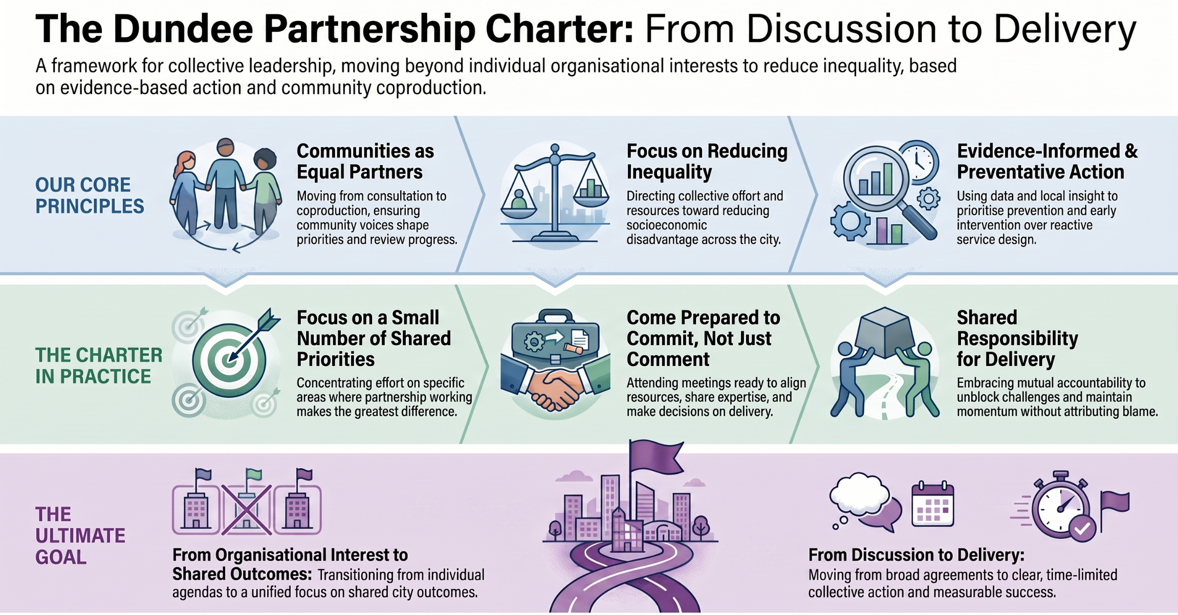

Dundee Partnership Charter

The below principles set out how partners in the Dundee Partnership will work together to deliver shared outcomes for the city. They are grounded firmly in Community Planning practice and Scottish Government statutory and non-statutory guidance.

The Dundee Partnership Management Group (DPMG) provides strategic leadership, oversight, and coordination for the work of the Dundee Partnership, the city’s Community Planning Partnership (CPP).
The Group’s core purpose is to:
- Drive delivery of the Dundee City Plan (Local Outcomes Improvement Plan)
- Ensure collective leadership and accountability across partners
- Focus on improving outcomes and reducing inequalities across Dundee
- Provide a mechanism for joint decision-making and strategic alignment

Shared Commitment to Reducing Inequality and Improving Outcomes
We will work collectively to improve outcomes for people and communities in Dundee, with a clear and sustained focus on reducing inequalities of outcome resulting from socio-economic disadvantage.
This will be achieved through a focused set of shared priorities agreed by the Partnership, with collective effort directed to where it will have the greatest impact.

2. Communities as Equal Partners in Planning and Delivery
We will treat communities as equal partners—working with communities of place and interest to shape priorities, coproduce solutions, and review progress.
We will clearly set out how community voices are heard and acted upon, including through Local Community Planning Partnerships (LCPPs), thematic groups, and direct community representation within Dundee Partnership structures. This will be reinforced through ensuring that two-way, transparent communications let communities see where their input has influenced decisions and actions.

3. Collaborative Leadership, Trust, and Mutual Accountability
We will lead collaboratively, build relationships based on trust and respect, and hold ourselves collectively accountable for delivering agreed actions and outcomes. A Partnership Work Plan will be maintained that will include actions agreed by the DPMG along with the leads, timescales and review points for these. This will provide a clear mechanism for tracking progress and addressing under-delivery.
Partners will be expected to make clear and deliverable commitments aligned to shared priorities, including through the contribution of organisational resources, expertise, and influence.

4. Evidence Informed, Preventative and Place-Based Action
We will use evidence and local insight to focus on prevention, early intervention, and place-based solutions that respond to Dundee’s distinct communities. This will include using data, local intelligence, and community insights to prioritise actions and measure progress over time.

5. How We Will Work as a Partnership
The Dundee Partnership will adopt an action-focused approach to delivery, based on:
- A small number of clearly defined priority areas
- Time-limited or programme-based workstreams focused on delivery
- Lead partners and delivery groups driving forward specific actions
- The ability to bring in a wider group of partners, including community groups, and public, private and third sector organisations, as required for specific pieces of work
This approach will build on existing effective models from across the Partnership, including project-based delivery approaches.

6. Engagement & Participation
The Partnership will be supported by a clear and proportionate Engagement Plan which sets out:
- Who we will engage (including communities and stakeholders)
- How engagement will take place
- How feedback will influence priorities, decisions and delivery
Engagement activity will be aligned to Partnership priorities and will support both the development and review of the Dundee City Plan.

7. Partnership Working and Connections
The Dundee Partnership will actively strengthen connections across partnerships, including:
- Strategic Leadership Groups (SLGs)
- Local Community Planning Partnerships (LCPPs)
- Dundee Partnership Coordinating Group (DPCG)
- Protecting People Partnership and its sub-groups
- Relevant regional and neighbouring partnership work
The Partnership will also seek to engage as required with a broader range of stakeholders, including where appropriate private sector partners, to support delivery of shared priorities.

8. Planning for Impact and Success
At the outset of each priority or workstream, the Partnership will define:
- What success will look like
- How progress will be measured
- What will be reviewed at agreed intervals (e.g. annually)
The Partnership will use this to assess impact, inform improvement, and ensure accountability.

9. Supporting Delivery of the Dundee City Plan
Beyond these four principles, additional collaboration will be focused on supporting delivery of the Dundee City Plan ensuring that the Partnership is well positioned to deliver on a refreshed Plan from 2027 onwards. This will include
- Subsidiary groups within the Dundee Partnership i.e. the three SLGs, LCPPs, and the DPCG
- Two way exchange with the Scottish Government, featuring our Place Director in accordance with the Place Directors Charter
- Liaison with the Protecting People in Dundee partnership and its sub-groups
- Work with other Public, Private and Third Sector organisations, beyond those who are Dundee Partnership members, working within Dundee
- Communities, whether geographic in nature or communities of interest (e.g. sharing the same protected characteristic)
- Delivery of agreed priority work plans linked to the City Plan
- Regular Partnership-wide engagement to inform future City Plan development

Dundee Partnership Management Group Terms of Reference

1. Purpose
The Dundee Partnership Management Group (DPMG) provides strategic leadership, oversight, and coordination for the work of the Dundee Partnership, the city’s Community Planning Partnership (CPP).
The Group’s core purpose is to:
- Drive delivery of the Dundee City Plan (Local Outcomes Improvement Plan)
- Ensure collective leadership and accountability across partners
- Focus on improving outcomes and reducing inequalities across Dundee
- Provide a mechanism for joint decision-making and strategic alignment

2. Functions and Responsibilities

Strategic Leadership
The DPMG will:
- Provide strategic direction for the Dundee Partnership through its priorities. This includes providing direction and support for the three Strategic Leadership Groups (SLGs):
  - Tackling Child Poverty and Inequalities in Income, Health, and Education
  - Inclusive Economic Growth
  - Tackling Climate Change & Reaching Net Zero
- Ensure alignment with national policy and legislative requirements (e.g. the Community Empowerment (Scotland) Act 2015)
- Agree and oversee a clear Partnership Work Plan, including priority actions, lead partners, timescales, and review points

Performance and Accountability
The DPMG will:
- Monitor progress against the Dundee City Plan, the Partnership Work Plan, and associated delivery plans
- Ensure that agreed actions are delivered and that progress is regularly reviewed and reported
- Oversee performance, using data and evidence from the above to inform decision-making
- Ensure partners are collectively accountable for agreed outcomes. Where delivery is not progressing as expected, agree corrective action

Partnership Coordination
The DPMG will:
- Provide oversight of:
  - Strategic Leadership Groups
  - Dundee Partnership Coordinating Group
  - Local Community Planning Partnerships
- Promote collaborative working, resource sharing, and joint problem-solving to support the delivery of agreed priorities
- Strengthen links with wider partnerships and groups to support coordinated action

Governance and Decision-Making
The DPMG will:
- Agree strategic priorities, actions, and key partnership decisions
- Agree and recommend the final Dundee City Plan and its annual reports to relevant governance bodies where required
- Ensure effective governance arrangements are in place and regularly reviewed

Engagement and Accountability to Communities
The DPMG will:
- Ensure community voice informs strategic planning through clearly defined structures and processes, including community membership of the DPMG
- Promote transparency and public accountability by showing how community voices have helped shape decisions

3. Membership
Membership will comprise senior representatives from Dundee Partnership statutory and key partner organisations, including:
- Dundee City Council
- NHS Tayside
- Police Scotland
- Scottish Fire & Rescue Service
- Skills Development Scotland
- Scottish Enterprise
- Third Sector Interface / key third sector partners
- Further and Higher Education institutions

Members will:
- Hold sufficient seniority to make decisions and commit resources
- Represent their organisation and contribute to collective leadership
- Ensure effective communication between the DPMG and their organisation

4. Chairing Arrangements
- The Chair of the DPMG will rotate on a periodic basis (e.g. annually) among statutory partners as agreed in December 2025.
- The Chair will be responsible for:
  - Setting agendas (in collaboration with support officers)
  - Facilitating meetings and ensuring effective participation
  - Representing the Partnership externally where appropriate

5. Meetings
- The DPMG will meet quarterly, with additional meetings arranged where required
- Meetings will:
  - Be formally minuted
  - Include a focus on performance, delivery, and decision-making
  - May take different formats, including action-focused sessions, workshops, and development sessions, to support effective partnership working
- A Partnership Work Plan will be maintained

Quorum
- A quorum will be defined as a minimum number of ten partner organisations represented (to be agreed)

6. Decision-Making
- The DPMG will operate on the basis of consensus wherever possible
- Where consensus cannot be reached, requests for additional information or action can be requested to enable decisions to be taken as soon as effectively possible
- For time sensitive issues the Chair of the group may call for a vote from amongst members present (one vote per organisation)

7. Roles and Expectations of Members
Members are expected to:
- Attend and actively contribute to meetings
- Provide strategic leadership and champion partnership priorities
- Commit to active participation in agreed priority workstreams
- Share relevant data, intelligence, and resources
- Ensure alignment between partnership activity and organisational priorities
- Support delivery through alignment of organisational activity and resources
- Act in accordance with the principles of trust, collaboration, and mutual accountability
When members are unable to attend, a suitable substitute should attend. Substitutes should be briefed on agenda items and able to contribute meaningfully to discussions and decision making.

8. Reporting and Accountability
The DPMG will:
- Enable its members to report through appropriate governance structures (e.g. DCC via relevant committees, NHS Tayside to the NHS Tayside Board, etc.
- Maintain oversight of relevant delivery structures and Partnership workstreams and suggest improvements where appropriate
- Provide and receive updates to / from partners, stakeholders, and community structures through two-way communications

9. Support
- The DPMG will be supported by the Dundee Partnership team, who will:
  - Coordinate meetings
  - Prepare agendas and papers
  - Maintain records and action logs
  - Support performance reporting and analysis

10. Review of Terms of Reference
- These Terms of Reference will be reviewed annually or as required
- Any changes will be agreed by the DPMG

11. Guiding Principles
All activity of the DPMG will align with the Dundee Partnership’s principles:
- Collaborative leadership and shared commitment to tackling poverty
- Evidence-informed and preventative approaches
- Place-based and community-focused action
- Transparency, trust, and accountability
- Planning and delivery will involve local communities

Meeting Partnership Responsibilities
Partners are expected to actively fulfil the commitments set out in this Charter, including;
- Contributing to shared priorities
- Participating in governance arrangements
- Supporting delivery through the alignment of organisational activity and resources
Where challenges arise in meeting these responsibilities, partners will work collectively and constructively to address them, maintaining a focus on trust, transparency, and shared accountability for outcomes.
Where concerns persist regarding a partner’s engagement or contribution, these should be raised through appropriate Dundee Partnership governance structures, including the Dundee Partnership Management Group or DCC’s Community Planning Team.
The Partnership will seek to resolve issues through dialogue, peer support, and collaborative problem-solving. Escalation, where required, will be through organisational leadership and governance routes and will be to support delivery, maintain trust, and resolve issues early. This approach reflects the principles of mutual accountability and continuous improvement that underpin Community Planning in Scotland.
The Partnership will maintain a clear and auditable Work Plan, setting out agreed actions, responsibilities, and timescales. This will be reviewed regularly and updated as required to reflect progress and emerging priorities.

What This Charter Means in Practice
This Charter is not simply a statement of shared ambition. It sets out how Dundee Partnership members are expected to work together, make decisions, contribute to delivery and hold each other to account.
In practice, this means partners will:
1. Focus on a small number of shared priorities
We will concentrate collective effort on the priorities where partnership working can make the greatest difference to Dundee’s people, places and communities. This means being disciplined about what we take on, avoiding duplication, and focusing on work that has clear purpose, ownership and impact.
- Come prepared to commit, not just comment
Members are expected to attend meetings ready to contribute actively, make decisions where appropriate, and identify how their organisation can support agreed priorities. This may include aligning existing activity, sharing data or insight, contributing staff time or expertise, using influence, or helping unblock delivery challenges.
- Put communities at the centre of planning and delivery
Community engagement should not be treated as a one-off consultation exercise. Partners should be able to show how communities, particularly those experiencing inequality or disadvantage, have helped shape priorities, decisions and delivery. We should also be clear with communities about what has changed as a result of their involvement.
- Use evidence, insight and local knowledge to guide action
Decisions should be informed by data, lived experience, professional judgement and local intelligence. We will use this evidence to understand need, target resources, measure progress and adapt our approach where something is not working.
- Work through clear delivery arrangements
For each agreed priority or workstream, the Partnership will identify what success looks like, who is leading, what actions are required, what partners will contribute, and when progress will be reviewed. These commitments will be captured through a clear Partnership Work Plan.
- Share responsibility for delivery
The Partnership is based on collective leadership and mutual accountability. Where progress is not being made, partners should work together constructively to understand the barriers, agree corrective action and maintain momentum. Accountability should be seen as a way of supporting delivery, not attributing blame.
- Connect partnership activity back into our own organisations
Members are expected to ensure that Dundee Partnership priorities are understood within their own organisations and, where appropriate, reflected in internal planning, governance and decision-making. The Partnership should not sit separately from organisational priorities; it should help align them around shared outcomes for the city.
- Behave in ways that build trust
Effective partnership working depends on openness, honesty, respect and follow-through. Members should be clear about what they can and cannot commit to, raise issues early, support shared problem-solving, and act in the interests of Dundee as a whole.
In simple terms, this Charter means that Dundee Partnership members are expected to move from discussion to delivery, from individual organisational interest to shared city outcomes, and from broad agreement to clear collective action.

This is a core statutory purpose of Community Planning in Scotland. CPPs have a legal requirement to act on this (Community Empowerment (Scotland) Act 2015)and national guidance repeatedly frames CP as the primary delivery vehicle for public service reform and tackling deep rooted inequality. There is a strong push in Scottish Government guidance on focusing collective resources ‘where they will add the most value’.
Guidance states that consultation is no longer sufficient. CPPs are expected to move towards participation, influence and coproduction, particularly with communities experiencing disadvantage. It also states that community participation is ‘at the heart of community planning’ across design, delivery and review. The strengths of communities and services need to be combined. The Community Empowerment Act requires CPPs to ‘make all reasonable efforts to involve communities affected by socio-economic disadvantage.
Relationships and leadership behaviours across CPPs are highlighted in Improvement Service materials as being as important as formal governance. Clear roles and shared accountability are also critical enablers of effective partnership working. CPIB guidance on fair funding highlights that trust-based relationships and proportionate accountability should apply across CPPs, promoting a culture of joint ownership and multi-partner delivery.
Guidance constantly stresses the use of evidence, locality intelligence, and preventative approaches rather than reactive service design. Being data-led enables better targeting of those most in need as well as better assurance of any changes achieved.

