Online Guidance for Landlord Registration

Website: www.landlordregistrationscotland.gov.uk
This is the initial screen, with 3 options:
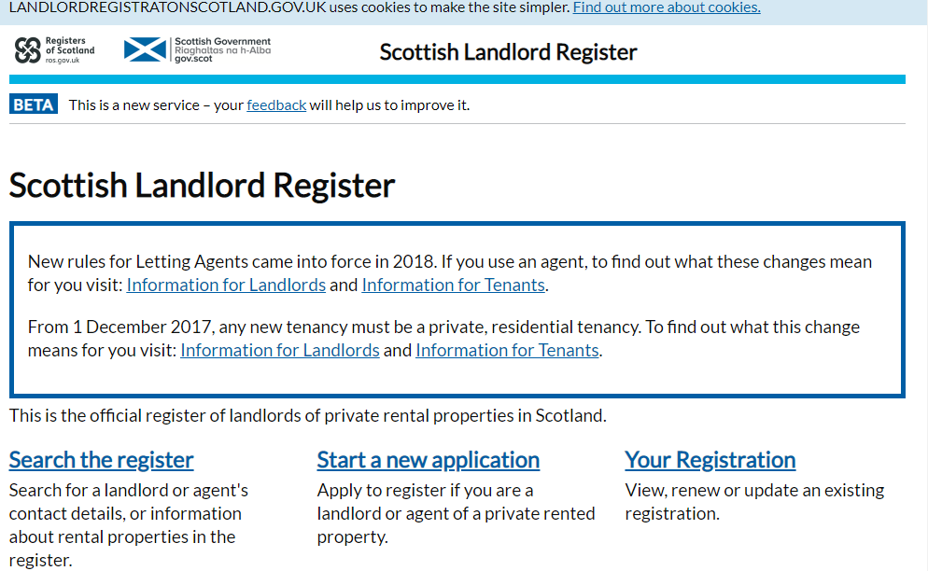

Option 1
Use ‘Search the register’ to check if a landlord is registered, or if you are trying to find the contact information for the landlord of a particular rental address. You will need either a landlord registration number, or the postcode of the rental property.
Option 2
‘Start a new application’ is for those of who are applying to become a registered landlord for the first time.
Option 3
Select ‘Your Registration’ in order to view, renew or update your existing application e.g. add/remove a property, update home address etc.
_________________________
When selecting Option 3, ‘Renew or update an existing registration’ you will be asked to select the most appropriate description; is your application as an individual or as an organisation.
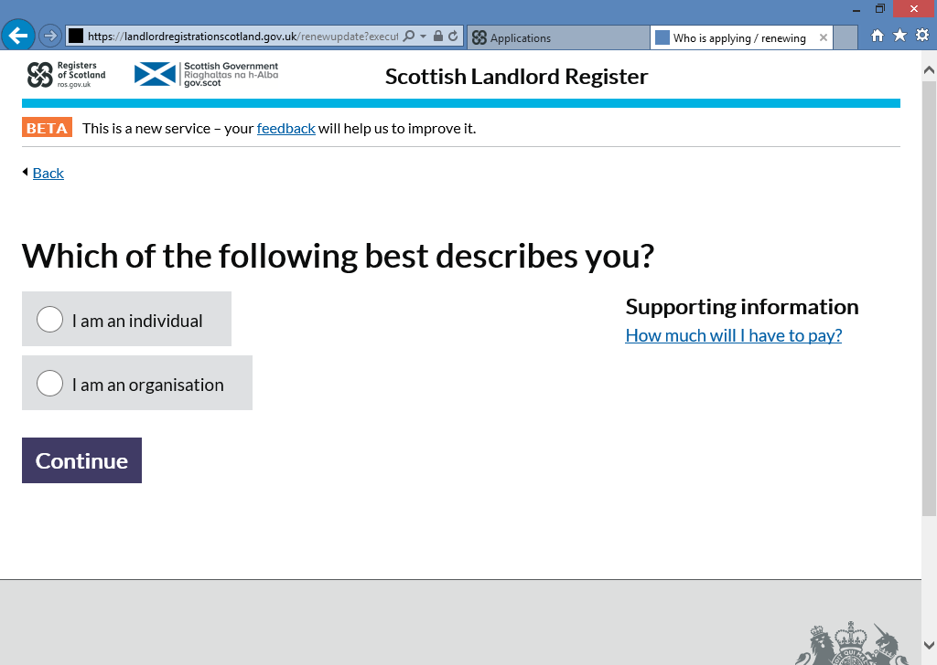

Enter the requested information. These are the details held on the system, so if you have married since you last registered and have not already updated your application then use your maiden name to enable you to access your application.
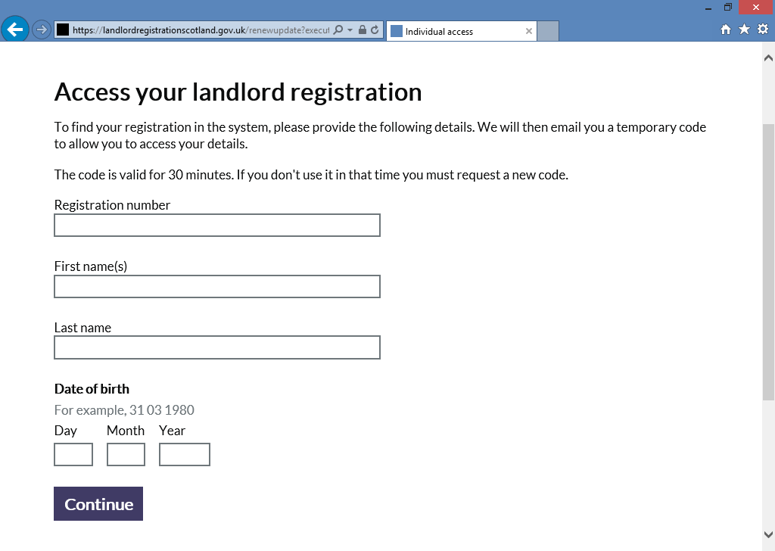
An email will be sent to you with a temporary code to allow you to complete the log in. If the email does not appear in your Inbox within a few minutes then check your Junk/Spam folder.
This code will allow you access into the system to make changes and/or renew your application.
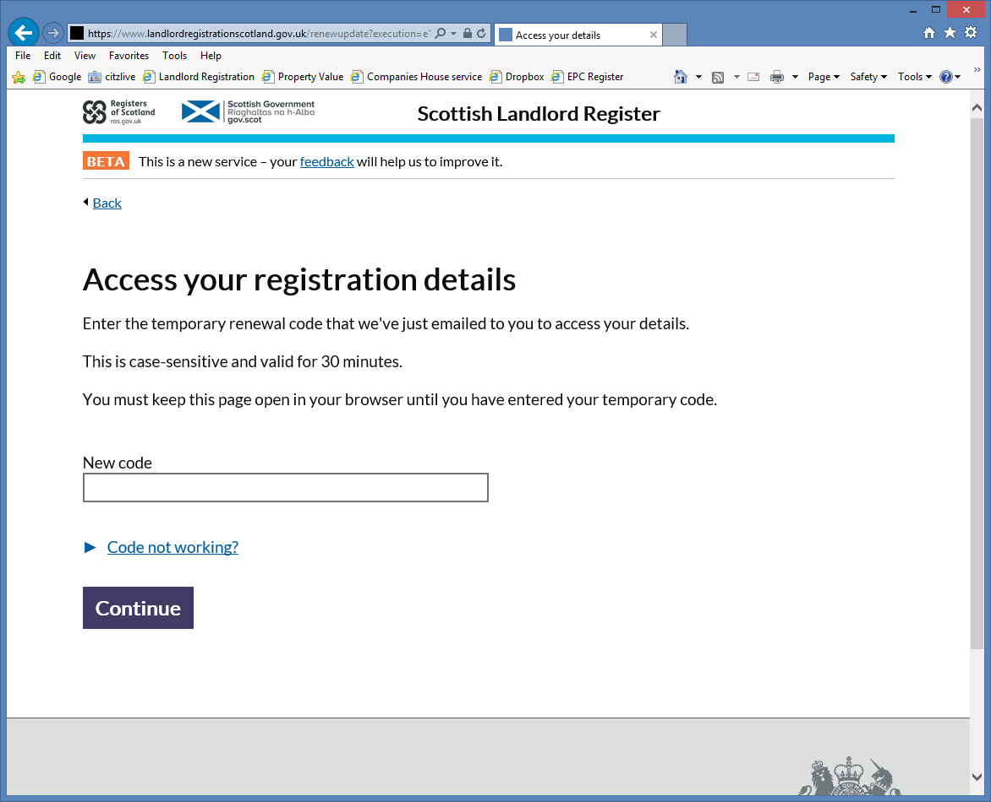

If you no longer have access to the email address listed on your existing registration application, or if you have not previously provided your email address, then contact the local authority so that this can be amended on your registration.
Remember to complete all changes and pay any fees due before moving away from the Landlord Registration website. The final screen should state ‘Application submitted’.

If you require assistance, or have any questions please contact the Landlord Registration Team:
Telephone: 01382 436849
Email: landlord.registration@dundeecity.gov.uk

