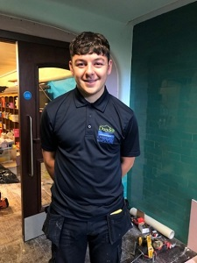

Hi, my name is Hari and I’m a 1st year Modern Apprentice Joiner with Dundee City Council, Neighbourhood Services and here’s my story…
A former pupil of Monifieth High School, Hari recently started his 4-year Modern Apprenticeship as a Joiner. He had been unsure what he wanted to do after leaving school so decided to stay on until 6th year. He felt a lot of pressure from school to go on to university however he knew this was not for him, that he did not want to go onto further or higher education.
After leaving school, he worked at Tesco Call Centre but soon realised that he was not cut out for a desk job and that he wanted to have an occupation that was more “hands-on”, a job with a physical aspect to it.
A local construction firm was fitting a new kitchen in his home and, as he watched the team at work, he thought this would be the sort of career that he would enjoy. He undertook 2 weeks’ work experience with the firm, one week with a joiner and one week with an electrician. He enjoyed the joinery side of things most, so then went on to undertake a few months of volunteering with another local Joiner’s business to provide him with more experience, whilst working in a bar at night. As time went on, he started to actively look for joinery apprenticeships and it wasn’t long before he found the job advert for a Joiner MA with Dundee City Council on My Job Scotland. He took great care with his application form to ensure it was thorough and accurate and got a family member to look over it before finally submitting it.
It’s early days for Hari as he just started in August 2022 but already says he’s loving it:
“I enjoy being on the tools. I’ve already had a wide variety of work, everyone I work with is great especially the journeymen who provide me with their knowledge and experience. Learning on the job works best of me. I also enjoy the block sessions when I have to attend the college. It’s a bit more relaxed compared to school where half the week is in the classroom and the other half is in the workshop.
My main difficulty was finding the right career path for me, but I truly believe that I have found it. I love getting up to go to work, it’s the first time I’ve had a job I really enjoy.”
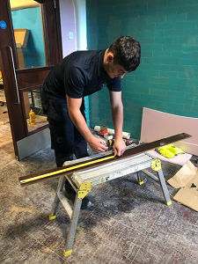
Hari measuring up onsite at Clepington Primary School during renovations.

